

**Addis Ababa Tegbare-id Polytechnic College**

**Biomedical Technology Department**

**Covid-19 Response Medical Equipment Maintenance Work Document**

**(Version 01)**

**May 30, 2020**

# Acknowledgment

First of all we would like to thank the almighty creator, without whom nothing would be possible. Next we like to thank the Administrative bodies of Addis Ababa Tegbare-id polytechnic college (AATPTC) for organizing and communicating with the Federal Ministry of Health (FMOH) and setup the Biomedical Technology Department at AATPTC to be one of the workshops for COVID-19 response. We also greatly admire their initiative to support our work by; providing materials we need in the process, bringing in supporting partners, assigning transport service for most of us and providing lunch for all volunteers working in the workshop. Our gratitude also goes to FMOH and all representatives for their commitment in organizing the collection of malfunctioned equipment from local and regional hospital and health office to our workshop, providing personal protective equipment and working together with us on ground level whenever possible.

The department greatly appreciates the fellow biomedical engineers and technicians that came from different work sectors as volunteers to provide support in maintenance. Last but not least we like to show our finest gratitude to the college and department partners, without whose help most activities would not be finished. We like to name each partner and volunteer by name, but in order not to push our future partners and volunteers away we choose not to until the work is done. Nevertheless you all know who you are,

Thank you and may you stay blessed.

Contents

Acknowledgment ii

Abstract v

Background 1

Maintenance Work Flow Process 3

1. Acceptance 4

2. Disassemble 6

3. Decontamination 6

4. Assembly 9

5. Pre-maintenance check 9

6. Maintenance 9

Troubleshooting of Patient Monitoring System 10

Troubleshooting of Fetal and Maternal monitor 10

Troubleshooting of Electrocardiograph 10

Troubleshooting of Pulse Oximeter 11

Troubleshooting of Oxygen Concentrator 11

7. Integration of Accessories 17

8. Test and Analysis 17

9. Decommission 18

Spare Parts and Accessories Required 19

Future Plans 22

A. Provide In-service training 22

1. Induction or Orientation Training 22

2. Refreshment Training 22

3. On-the-Job Training 22

B. Establish medical equipment maintenance center 23

C. Conduct Performance test and analysis of medical equipment 23

D. Establish capable incubation center 24

Appendix 25

I. Acceptance form 25

II. Standard of Operation 26

III. Decontamination Guideline 27

IV. Maintenance Form 32

V. Test and Analysis Form (ventilator unit) 33

VI. Decommissioning Form 36

Table 1: List of medical equipment with current status 2

Table 2: Accepted Medical Equipment Info 4

Table 3: Comparison of equipment arrived verse functional equipment requiring accessory 9

Table 4: Troubleshooting of Patient Monitoring System 10

Table 5: Troubleshooting of Fetal and Maternal monitor 10

Table 6: Troubleshooting of Electrocardiograph 11

Table 7: Troubleshooting of Pulse Oximeter 11

Table 8: Troubleshooting of Oxygen Concentrator 12

Table 9: Mechanical Spare Parts and Material for Medical Devices under Repair 21

Figure 1: Maintenance work flowchart 3

Figure 2: Notice Board of workshop (Decontamination guideline, SOP, check forms and flowchart from left to right) 3

Figure 3: Verifying used claim on a ventilator unit 5

Figure 4: Accepting equipment from Ras Desta Damtew Memorial Hospital 5

Figure 5: Visually soiled PMS 6

Figure 6: Visually soiled O2 concentrators 6

Figure 7: Decontamination of PMS 7

Figure 8: PMS after decontamination 7

Figure 9: Decontamination of Oxygen Concentrators 8

Figure 10: O2 concentrators after decontamination 8

Figure 11: Maintenance on PMS 13

Figure 12: Maintenance on PMS and pulse oximeter units 14

Figure 13: Maintenance on Oxygen concentrator unit 14

Figure 14: Maintenance of oxygen concentrator unit 15

Figure 15: Filling maintenance form 16

Figure 16: Documentation for accessory and spare part requirement 16

Figure 17: Reading through manual to develop test and analysis form 17

Figure 18: Conducting performance test on a ventilator unit 17

Figure 19: Analyzed mechanical ventilators at airport workshop 18

Figure 20: Equipment waiting for part and accessory (PMS. ECG and oxygen concentrators) 19

# Abstract

World health organization (WHO) defines Corona virus disease 2019 (COVID-19) as illness caused by a novel coronavirus, now called severe acute respiratory syndrome coronavirus 2 (SARS-CoV-2; formerly called 2019-nCoV). Since the declaration of the outbreak being a global health emergency on January 30, 2020 and then pandemic on March 11, 2020; we have been witnessing it taking the lives and livelihood of many. The first case in Ethiopia was confirmed on March 13, 2020 and the number has been increasing ever since. Around end of March, Prime Minister Dr. Abiy Ahmed made a call for all health professionals for assistance.

Following that call and having no classes’ trainers of the biomedical department at Addis Ababa Tegbare-id Polytechnic college (AATPTC) came together to an agreement to contribute professional support in fighting this pandemic by maintenance of medical equipment related with this case. At the same time knowing the capability of the department with both manpower and tool sets for maintenance the administrative body of the college worked together with Ethiopian Federal Ministry of Health (FMOH) to bring in medical equipment in to the college from both local and regional hospitals for maintenance.

To support this maintenance activity currently there are many volunteer biomedical engineers and technicians from different working sectors participating in the activity. To alleviate the requirement of personal protective equipment (PPE), decontamination materials, tools, spare-parts and accessories needed for maintenance the Administrative body and the biomedical department is working close with different partners of the college.

The following document comprises of the work that has been done, the workflow in which it’s done, the documentation used in the process and the list of requirements for maintenance work by the biomedical technology department of AATPTC for the response of Covid-19 (coronavirus) pandemic in Ethiopia.

# Background

As a response to COVID-19, Tegbare-id polytechnic college biomedical department is providing maintenance service for hospitals assigned by the MOH. The main objective of this maintenance activity is to contribute with professional support as per the call from Prime Minister Dr. Abiy Ahmed.

Starting from April 21, 2020 the biomedical department of AATPTC has organized a workshop in one of the colleges building and started maintenance of medical equipment. The medical equipment that is given priority for maintenance is types of medical equipment that are used in intensive care units and are directly involved in the diagnosis and therapeutic of COVID-19 patients.

The diagnostics equipment received are patient monitoring systems, pulse oximeters and Electrocardiographs. The therapeutic/life supporting equipment received are oxygen-concentrators and defibrillator.

For ventilator units the AATPTC biomedical department provides only performance and electrical safety test and analysis of the maintained mechanical ventilator before they are applied to the patient. Different ventilator unit supplier companies are using their own biomedical engineers/ technicians and working together with the workshop technicians at airport to maintain mechanical ventilators. Because they can better access and provide the spare part and accessories needed for the equipment, when ventilator units arrive in the college biomedical department, the FMOH collects it and sends it to the airport workshop. So far AATPTC biomedical department have conducted performance and electrical safety test for 32 mechanical ventilators.

In total, 90 medical equipment with 30 different model types were accepted to be maintained by the department. Out of which 24 came in functional requiring accessories and part, 66 came in nonfunctional. Out of the 66 that were nonfunctional 36 are maintained and made functional, 24 require spare part to be functional and 6 are considered beyond repair and are used as spare part supply. All medical equipment requires accessories and part, the required list is written on a later section of this document and on Excel sheet attached together with this document.

The table below shows list of the medical equipment with it is current status.

|  |  |  |  |  |  |  |  |
| --- | --- | --- | --- | --- | --- | --- | --- |
| Equipment Name | T.A | Brand / Model | A | F.NA | M.NA | NF.NS&A | BR |
| Patient Monitor System | 46 | BLT/ ANY VIEW A8 | 18 | 5 | 9 | 3 | 1 |
| YONKER/ YK-8000C | 3 | 3 |  |  |  |
| AEOMED/ Caredo F2 | 6 | 1 |  | 3 | 2 |
| NT PLUS/ MP 1000 | 2 |  | 2 |  |  |
| MINDRAY/ MEC 1000 | 2 | 1 | 1 |  |  |
| MINDRAY/ IMEC 10 | 1 |  |  | 1 |  |
| MINDRAY/PM 9000 | 1 | 1 |  |  |  |
| MINDRAY/BeneView T8 | 1 |  | 1 |  |  |
| BLT /V6 | 3 | 2 | 1 |  |  |
| NIHON KOHDEN (LIFE SCOPE) | 1 |  |  | 1 |  |
| COMEN/ STAR 8000 | 3 |  |  | 3 |  |
| PHILIPS/ M3 | 1 |  | 1 |  |  |
| CONTEC/CMS 9200 | 1 | 1 |  |  |  |
| CONTEC/CMS 8000 | 2 | 2 |  |  |  |
| SCHILLER/ ARGUS LCX | 1 | 1 |  |  |  |
| Fetal and Maternal Monitor | 2 | COMEN/ STAR 5000C | 2 | 1 | 1 |  |  |
| Defibrillator | 1 | MINDRAY / BeneHeart D3 | 1 | 1 |  |  |  |
| Electrocardiograph | 3 | SCHILLER/ CARDIOVITAT-102 | 2 | 1 | 1 |  |  |
| YORK/ YORCO | 1 | 1 |  |  |  |
| Oxygen Concentrator | 30 | YUYUE/ 7F-5 | 25 | -- | 16 | 6 | 3 |
| FOLEE/ Y007-5 | 1 |  |  | 1 |  |
| DEVILBISS/ 525K2 | 2 |  |  | 2 |  |
| VS-W-NS | 1 |  | 1 |  |  |
| Elite AIRrEP/ NewLife | 1 |  | 1 |  |  |
| Pulse Oximeter | 8 | SCHILLER /Argus oxm | 2 |  |  | 2 |  |
| CONTEC/ CMS60C | 1 |  |  | 1 |  |
| NELLCOR/ OXIMAX N-600X | 1 |  |  | 1 |  |
| BLT/ M800 | 1 |  | 1 |  |  |
| OXIMETERPC-66B | 1 | 1 |  |  |  |
| MASIMO/ Rad-5 | 2 | 2 |  |  |  |
| Total | **90** |  | **90** | **24** | **36** | **24** | **6** |
| T.A- Total Amount  A- Amount  F.NA- Functional (need accessory)  M.NA-Maintained (need accessory)  NF.NS&A- Nonfunctional(need spare part and accessory)  BR - Beyond Repair (used as spare part) | | | | | | | |

Table 1: List of medical equipment with current status

# Maintenance Work Flow Process

There are nine stages followed by the department to conduct the work flow process. These stages are Acceptance, Disassemble, Decontaminate, Assemble, Pre-maintenance check, Maintenance, Integration of accessories, Test and Analysis and Decommission. In any of these stages it is our workshops rule to always wear personal protective equipment (gloves, gown and masks). The details and flowchart of these stages is described below.

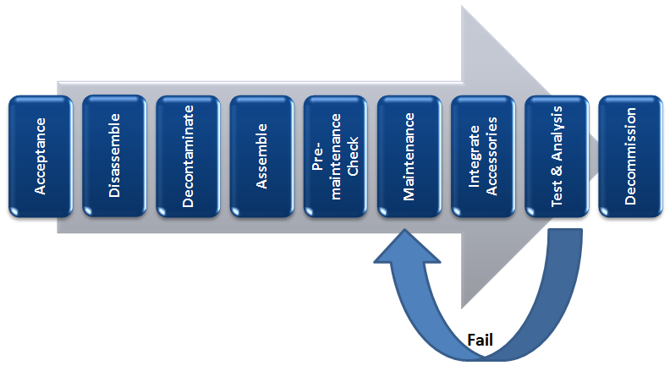

Figure 1: Maintenance work flowchart

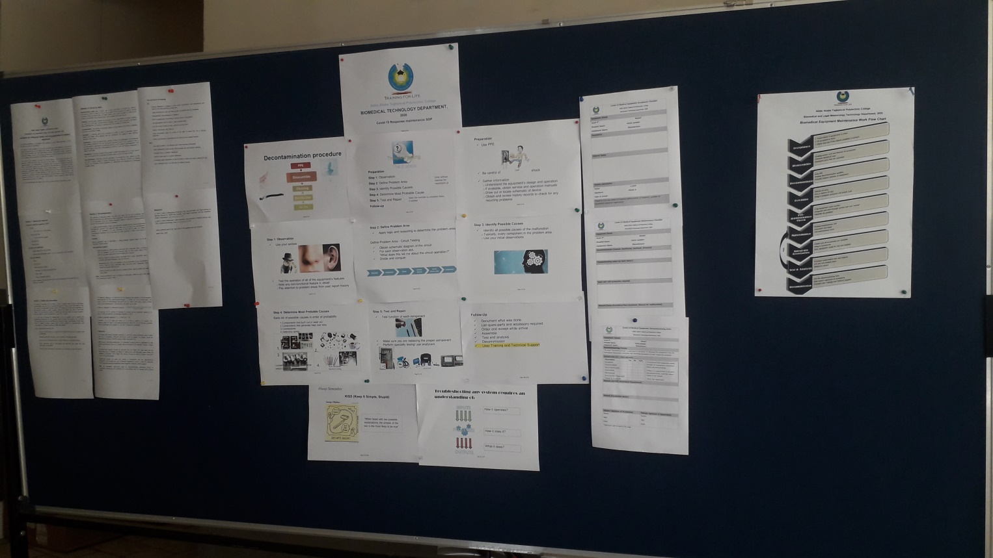

Figure 2: Notice Board of workshop (Decontamination guideline, SOP, check forms and flowchart from left to right)

## Acceptance

This is the stage where medical equipment that the hospitals bring to the college department workshop is accepted. In this stage the acceptance form is filled while verifying the claim that the user made (See Figure 3below). Because the medical equipment that came in the first and second round were visually soiled and showed clear signs of contamination; a general decontamination guideline was made which the user can follow and decontaminate their medical equipment before bringing it to the workshop. The guideline was then forwarded to the FMOH and they have taken over the responsibility of sharing it to the hospitals that wish to bring their equipment in for maintenance. Hence in this stage visual check of equipment cleanness is conducted.

History and status of the equipment is written in this section by information provided by the user or the biomedical engineer/technician responsible for the equipment. This was not possible for some of the equipment that arrived from the regional hospitals, as they sent the equipment by driver only. This had made the maintenance somewhat challenging.

|  |  |  |  |  |
| --- | --- | --- | --- | --- |
| Acceptance Date | Hospital Name | Total Amount of Equipment | Equipment name | Amount |
| April 21, 2020 | Ras Desta Damtew Memorial Hospital | 9 | Patent Monitoring System | 7 |
| Electrocardiograph | 2 |
| April 21, 2020 | Zewditu Memorial Hospital | 4 | Patent Monitoring System | 4 |
| April 22, 2020 | Alert Hospital | 16 | Patient Monitoring System | 11 |
| Defibrillator | 1 |
| Electrocardiograph | 1 |
| Vital Sign Monitor | 3 |
| April 29, 2020 | Tulu Bolo General Hospital | 4 | Patent Monitoring System | 2 |
| Oxygen Concentrator | 2 |
| April 29, 2020 | Robi Dida General Hospital | 15 | Pulse Oximeter | 3 |
| Oxygen Concentrator | 12 |
| April 29, 2020 | Gara Muleta General Hospital | 1 | Patent Monitoring System | 1 |
| May 1, 2020 | West Guji Zone Health office | 20 | Patent Monitoring System | 1 |
| Pulse Oximeter | 5 |
| Oxygen Concentrator | 14 |
| May 15, 2020 | Harameya General Hospital | 4 | Patent Monitoring System | 2 |
| Oxygen Concentrator | 2 |
| May 17, 2020 | South Nation Nationality Regional Health Bureau | 17 | Fetal and maternal monitor | 2 |
| Patent Monitoring System | 15 |
| Total of 90 medical equipment. From 6 Hospitals, 1 health office and 1 health bureau, | | | | |

Table 2: Accepted Medical Equipment Info

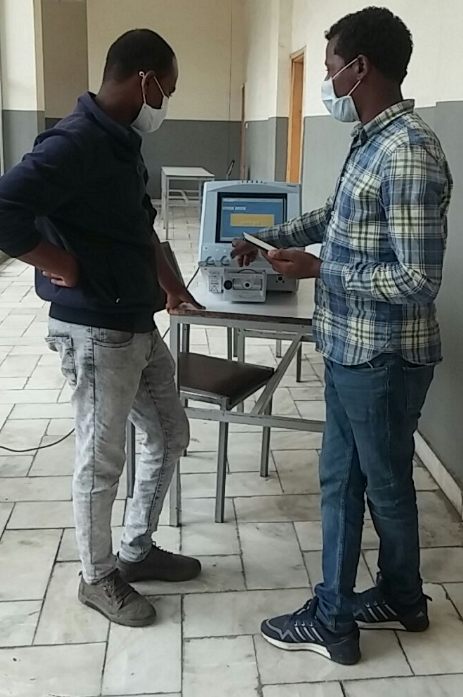

Figure 3: Verifying used claim on a ventilator unit

(Unit later transferred to airport workshop)

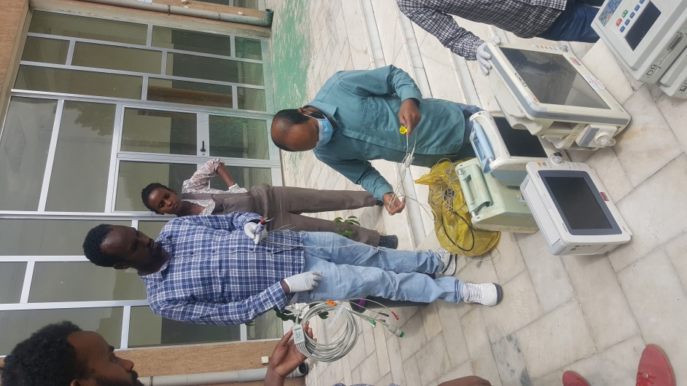

Figure 4: Accepting equipment from Ras Desta Damtew Memorial Hospital

(Counting accessories brought by the hospital, most were not fitting to the equipment they brought)

## Disassemble

This is the stage where preparation for the decontamination process begins. Accessories, battery (if any) and power cord of the equipment are unplug and remove. It’s also required to demount any parts that are mounted on the equipment.

## Decontamination

This is the stage where we clean and disinfect the equipment by following the decontamination guideline. On this stage heavy duty gloves are preferred to be used on top of the latex gloves, in order to avoid contact between liquid cleaning solutions and the biomedical engineer/ technician. Visually inspecting cleanness of the equipment is the last step of this stage.

Equipment accepted is treated as contaminated and all went through basic decontamination process. Covers were cleaned and disinfected, whenever necessary machine was opened and cleaned inside. With all oxygen concentrator units internal part was cleaned with blower and tubes and filters, side cabinet cover (filter holder) thoroughly cleaned by washing. Cleaning is not only a decontamination process but also part of maintenance; it contributes to the longevity of the equipment.

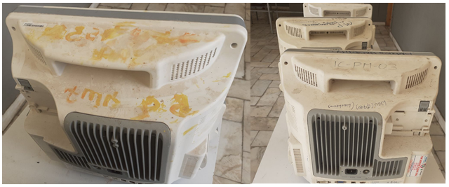

Figure 5: Visually soiled PMS

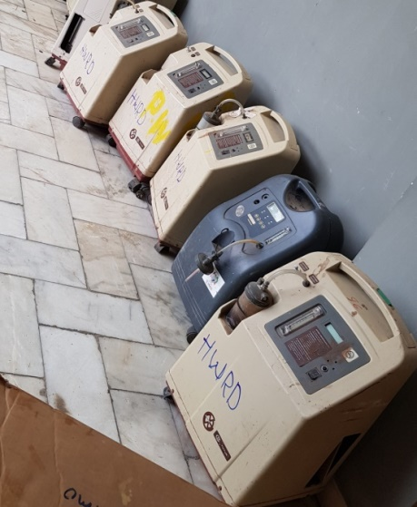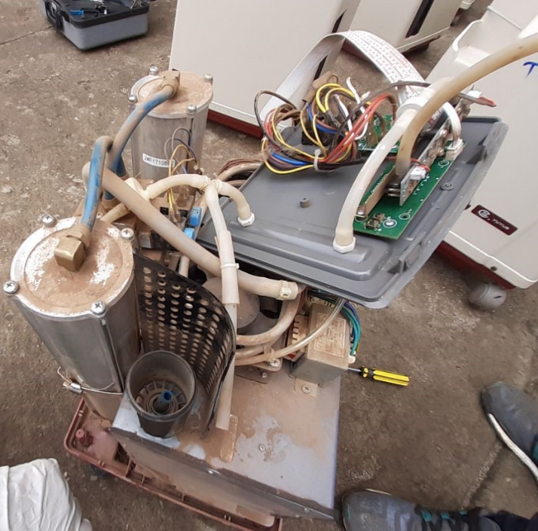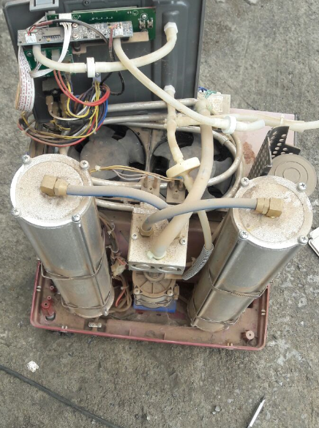

Figure 6: Visually soiled O2 concentrators

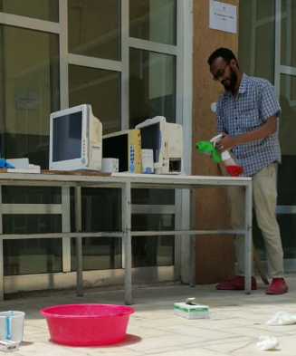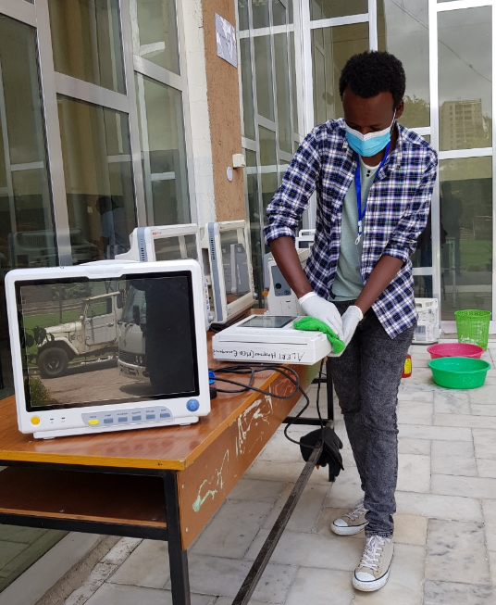

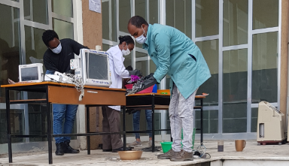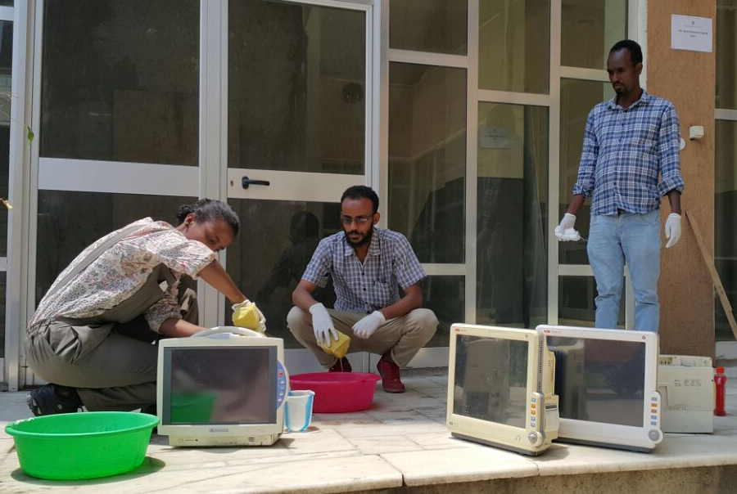

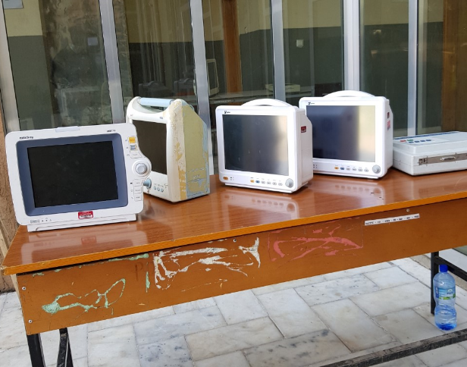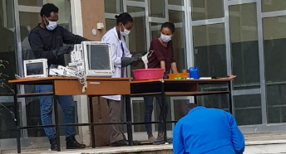

Figure 7: Decontamination of PMS

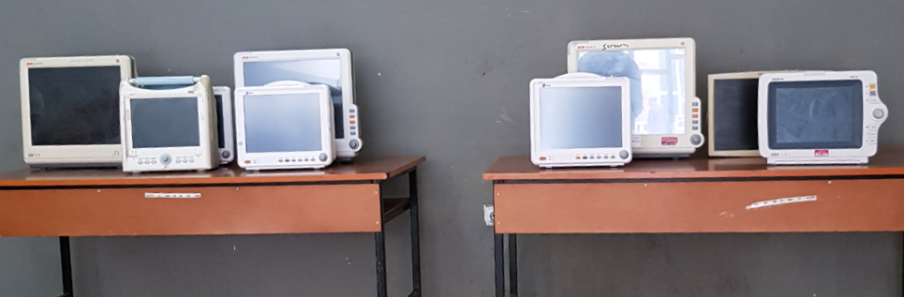

Figure 8: PMS after decontamination

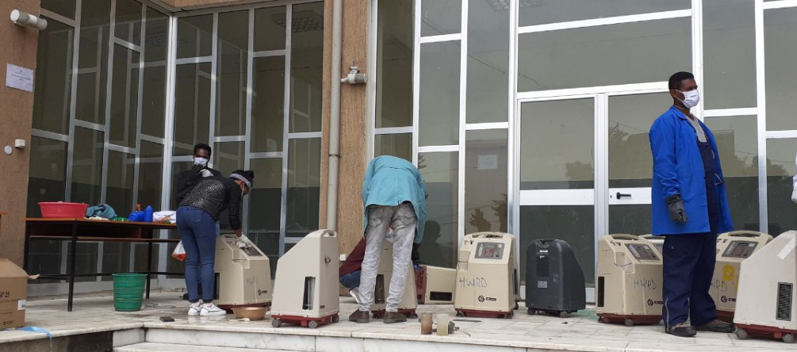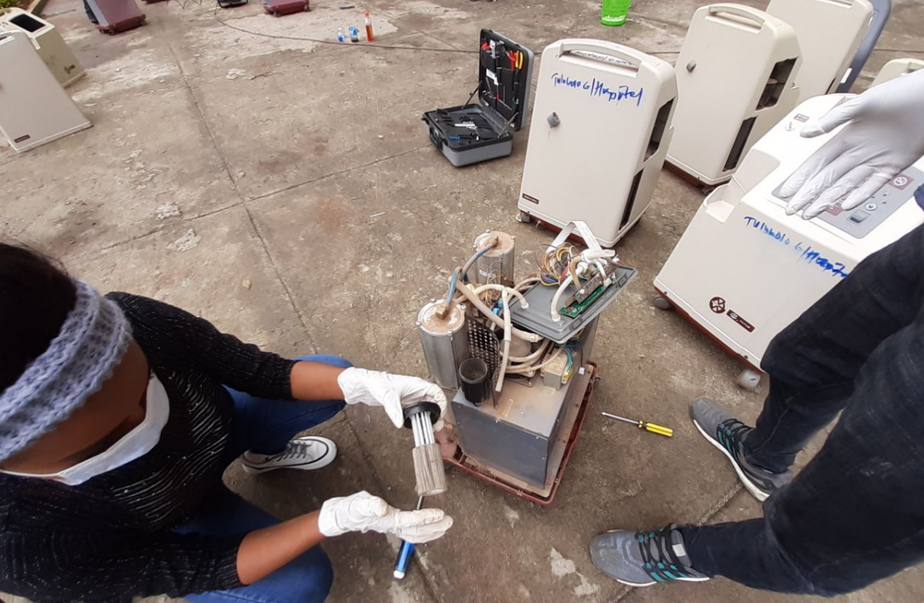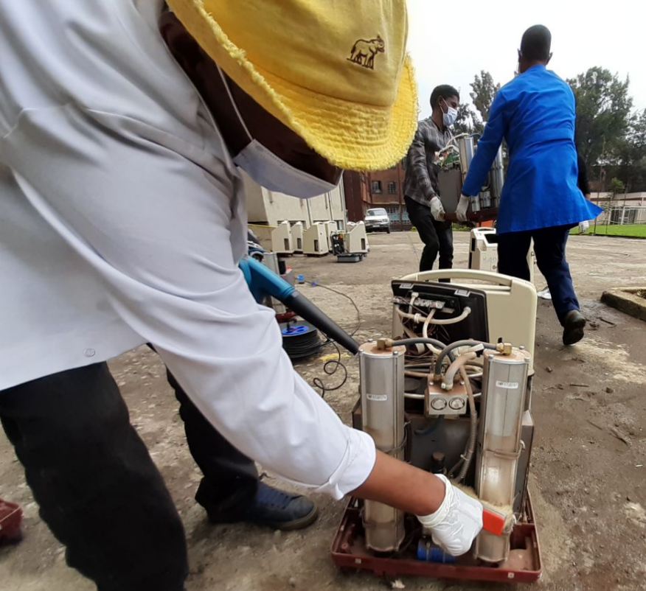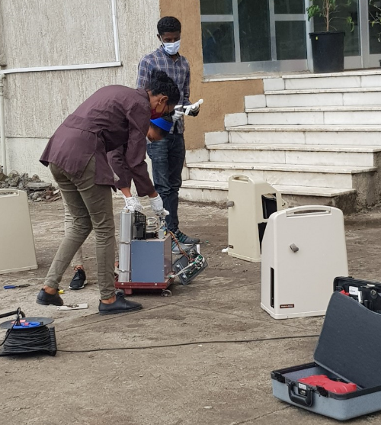

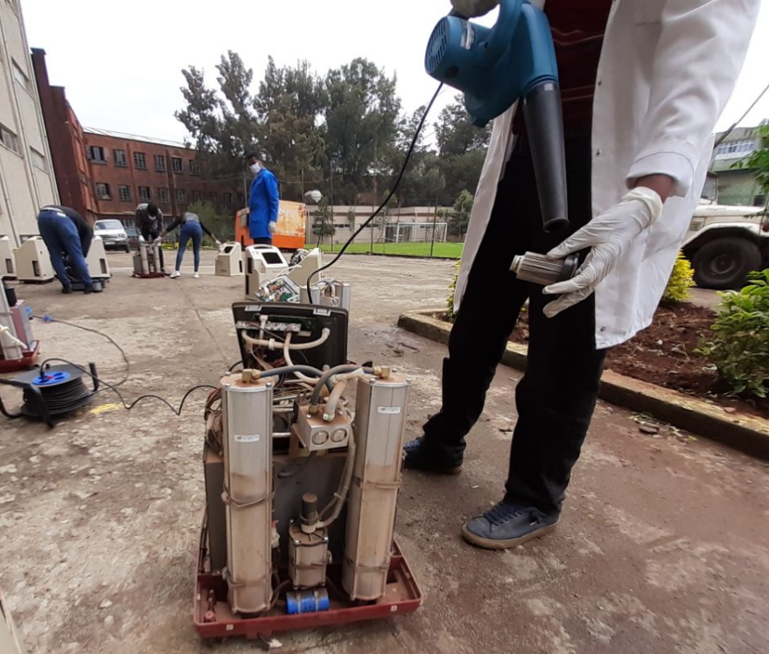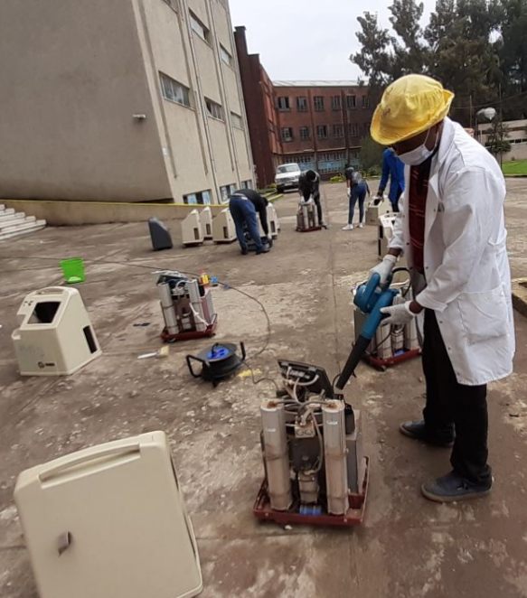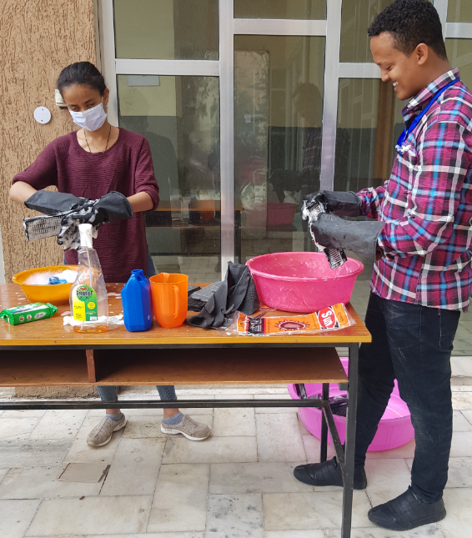

Figure 9: Decontamination of Oxygen Concentrators

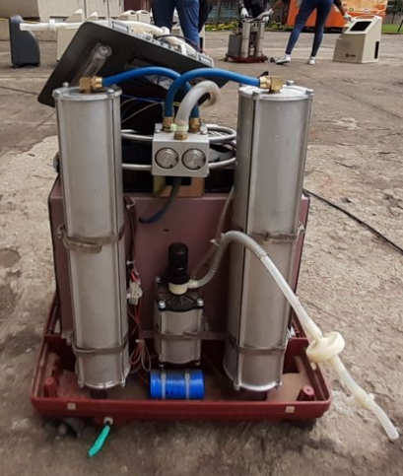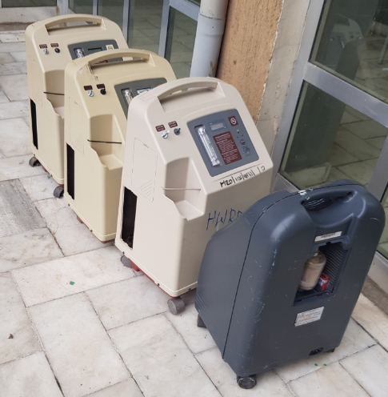

Figure 10: O2 concentrators after decontamination

## Assembly

This is the reverse of the disassembly stage. All the accessories and parts that were removed are plugged in and mounted back on the equipment.

## Pre-maintenance check

In this stage the equipment is tagged with the asset number given to it on the acceptance form. Both service and user manual will be organized and the biomedical engineer/ technician skim through it and then work on identifying the problem.

Out of the 90 medical equipment that came in for maintenance 24 came in functional requiring only accessories and battery. For better comparison refer the table below.

|  |  |  |
| --- | --- | --- |
| Equipment Name | Total Number | Functional (need accessory) |
| Patient Monitoring System | 46 | 17 |
| Fetal and maternal monitor | 2 | 1 |
| Defibrillator | 1 | 1 |
| Electrocardiograph | 3 | 2 |
| Pulse Oximeter | 8 | 3 |
| Oxygen Concentrator | 30 | 0 |

Table 3: Comparison of equipment arrived verse functional equipment requiring accessory

After integration of accessories; performance test of the equipment will show the correct function of the equipment. Although full functionality of this equipment is to be determined after the performance and electrical safety test, the department believes that the problem these equipment have could have been solved in their respective hospitals. So it is our recommendation that the Ethiopian Federal Ministry of Health (FMOH) conducts a thorough investigation as to why the hospitals are unable provide the accessories needed for complete functionality of their equipment, focusing on procurement process and stock keeping.

The AATPTC Biomedical department relies on the colleges and department partners to supply the accessories and batteries required for full functionality of the equipment. The list of accessories and batteries required are written in the “Accessories and Spare Part Required” section.

## Maintenance

For this stage standard of operation (SOP) is drafted by the department. This is the stage where maintenance and repair of the medical device is conducted. After repair each maintenance activity is documented and filled in the maintenance form properly.

Since description of complete troubleshooting procedure is cumbersome general description of what the problem was faced and what was done is described briefly in the tables below.

### Troubleshooting of Patient Monitoring System

|  |  |  |
| --- | --- | --- |
| **Fault** | **Problem Identified** | **Corrective action taken** |
| Machine doesn’t turn on | Power supply unit damaged | Replace damaged components with the correct setting |
| Loss connection | Fixed |
| Power supply (switching transformer failed) | Replace whole board to avoid complication with electrical safety |
| On/off switch not working | Membrane key doesn’t teach internal switch | Modification to make contact point between switch |
| Selector switch not working | Push button doesn’t reach contact point | Modified |
| No display | Loss connection | Fixed |
| Damaged screen | Screen replacement (waiting for part to arrive) |
| Damaged high voltage fly back transformer | Changed and repaired |
| NIBP cuff doesn’t inflate | Damaged sensor on main board | Replacement of board (waiting for part to arrive) |
| Interface of SpO2 probe with unit | EMS module SpO2 appliance connecter has broken pin inside | Change SpO2 appliance connecter if accessible, if not change EMS module (waiting for part to arrive) |
| EMS module display goes off after few minutes | loss cable connection between LCD and mainboard | Fixed |
| Machine display goes off continuously | Main processor board | Replaced |
| SpO2 signal detection | User problem (using incorrect probe and setting) | Perform factory reset, user training required on decommissioning |
| Error message SpO2 off | Faulty sensor | Replace (waiting for accessory to arrive) |
| Blurred display | Loss connection of LCD wire | Repaired |
| EMS module can’t be interfaced | EMS module socket tilted to the side | Repaired |
| NIBP not pump | Unit pump is missing | Replace (waiting for part to arrive) |

Table 4: Troubleshooting of Patient Monitoring System

### Troubleshooting of Fetal and Maternal monitor

|  |  |  |
| --- | --- | --- |
| **Fault** | **Problem Identified** | **Corrective action taken** |
| No display | Damaged screen | Replace (waiting for part to arrive) |
| NIBP over pressure Alarm/ noise from pump | Incorrect setting | Adjust setting/ give user training |

Table 5: Troubleshooting of Fetal and Maternal monitor

### Troubleshooting of Electrocardiograph

|  |  |  |
| --- | --- | --- |
| **Fault** | **Problem Identified** | **Corrective action taken** |
| Command keyboard was not functional | Dirt caused open contact point key membrane and internal board | Cleaned and fixed |

Table 6: Troubleshooting of Electrocardiograph

### Troubleshooting of Pulse Oximeter

|  |  |  |
| --- | --- | --- |
| **Fault** | **Problem Identified** | **Corrective action taken** |
| Machine doesn’t turn on | Blown fuse | Replacing fuse (waiting for correct fuse setting to arrive) |
| Broken battery holder pin | Modified (temporary solution) |
| Dead battery | Replaced |
| Dead battery, unit missing power adapter to charge battery | Replace (waiting for part to arrive) |

Table 7: Troubleshooting of Pulse Oximeter

### Troubleshooting of Oxygen Concentrator

For oxygen concentrator to be said fully functional, it has to be run 24 hour and pass the oxygen concentration and pressure output test. These tests could not be conducted because most units having missing filters (gross particle/ coarse, compressor/air inlet and HEPA/Bacteria filters) and tubes. For the safety of the equipment unit cannot be run without filter. All necessary parts to make the oxygen unit functional are written on “spare part and accessories required” section.

|  |  |  |
| --- | --- | --- |
| **Symptom** | **Problem Identified** | **Corrective action taken** |
| No output/ equipment turns off after minutes | Damaged four our way valve / fail to transfer air to canister which builds high pressure and shuts off the machine. | 4 way valve ordered (waiting for part to repair equipment) |
| Dust accumulated on tube | Cleaned |
| No output | Driver board component damaged | Replaced the damaged component (transistor) |
| Equipment turns off after seconds | Damaged main board | Replaced |
| Soiled main board | Cleaned with contact cleaner |
| Low oxygen concentration | Used up Zeolite material | Zeolite ordered (replacement of material or sieve bed is necessary, waiting for supply to repair) |
| Dirty gross particle filters | Washed and fixed |
| Dirty tubing | Cleaned |
| Missing gross particle filter | Replacement of filter (waiting for supply) |
| Dirty compressor inlet filter | Replacement of filter (waiting for supply) |
| Missing compressor inlet filter | Replacement of filter (waiting for supply) |
| Dirty HEPA/ Bacteria filter | Replacement of filter (waiting for supply) |
| Machine doesn’t turn on | Damaged internal wiring | Fix damaged wiring |
| Damaged capacitor | Replaced |
| Damaged transformer | Replaced |
| Damaged fuse | Replaced |
| Loss connection | Fixed |
| Low pressure | Leaking tube | Replace tube |
| Pressure regulator wrong setting | Pressure regulator adjusted with use of analyzer |
| Damaged pressure regulator | Replace (waiting for part arrival) |
| Open pneumatic circuit | Fixed |
| Damaged and missing power cord | Damaged/ Burned up due to high power | Replaced |
| Missing power cord | Replace (waiting for part arrival) |
| High pressure/ low oxygen output | Damaged pressure regulator | Replaced |
| Soiled/ clogged zeolite granules/Sieve bed | Replace Zeolite granules/ sieve bed (replacement of material or sieve bed is necessary, waiting for supply to repair) |
| Soiled Check valve | Cleaned |
| Broken on/off switch | Broken on/off switch | Modified |
| No display | Disconnected display board cable | Connected and soldered in place |
| Unit doesn’t turn on | Internal wiring and tube eaten by rats | Beyond repair, machine used as spare part |
| Display low oxygen error with good oxygen concentration output | Defective oxygen sensor | Replaced oxygen sensor |
| Broken casters | Broken casters | Replace (waiting for part arrival) |
| No flow meter | No flow meter | Replace flow meter (waiting for part arrival) |
| No flow meter knob | No flow meter knob | Replace whole flow meter set (waiting for part arrival) |
| Broken front panel | Broken front panel | Replaced |

Table 8: Troubleshooting of Oxygen Concentrator

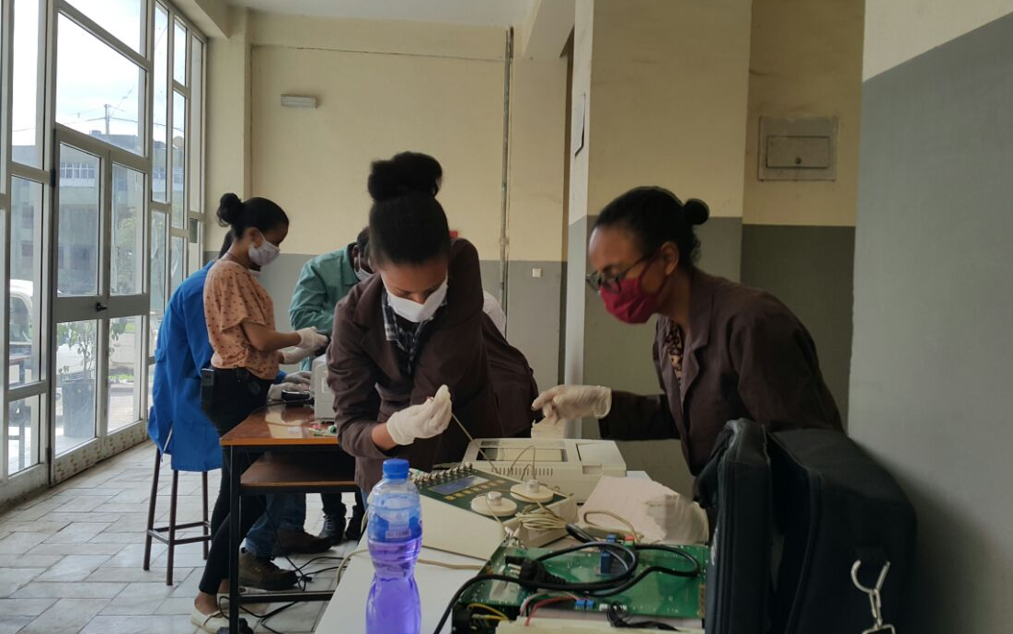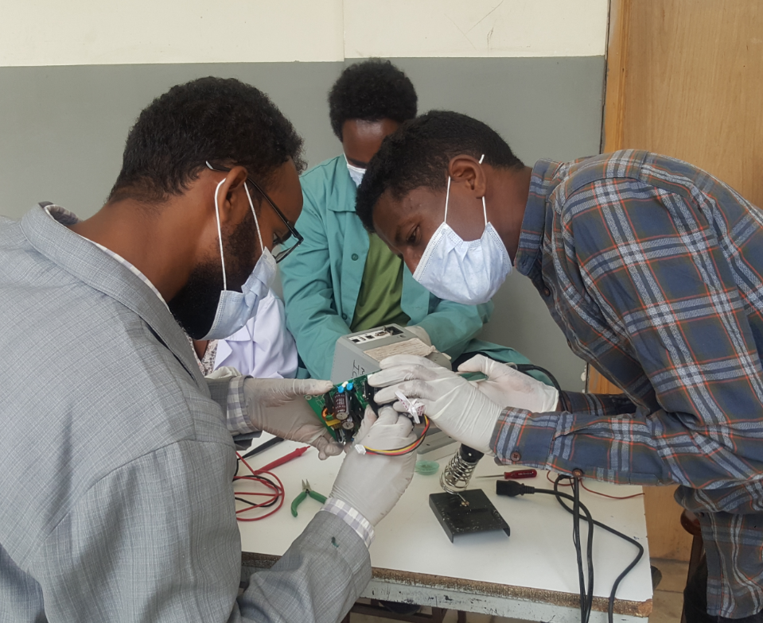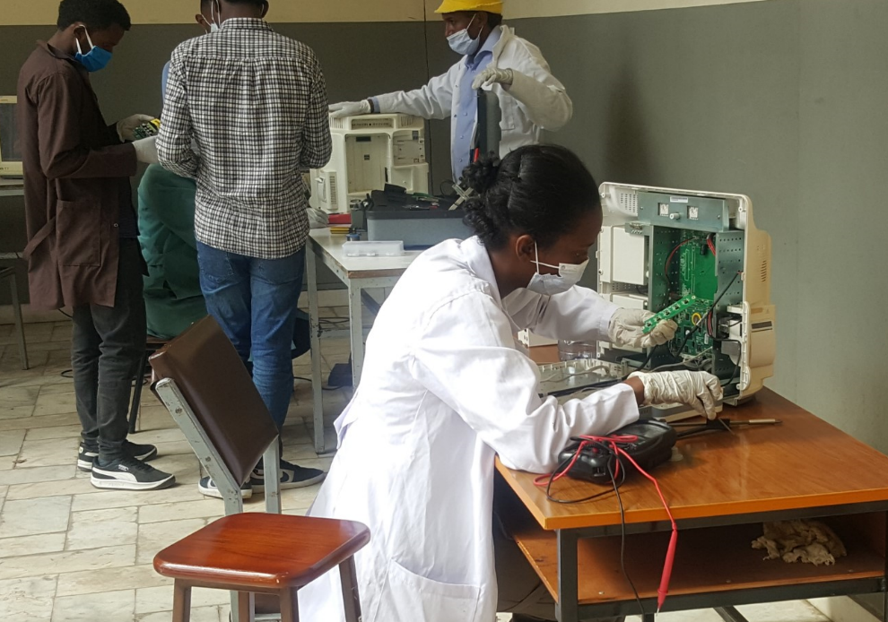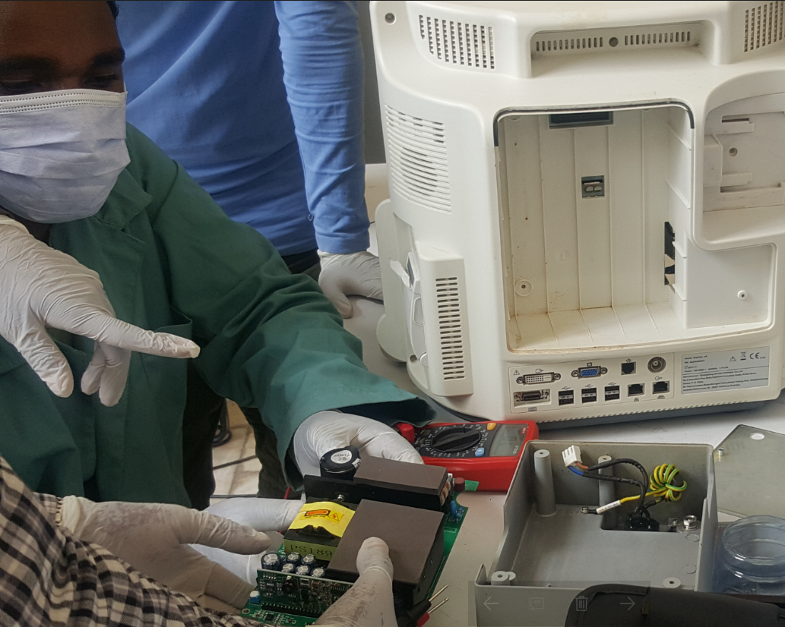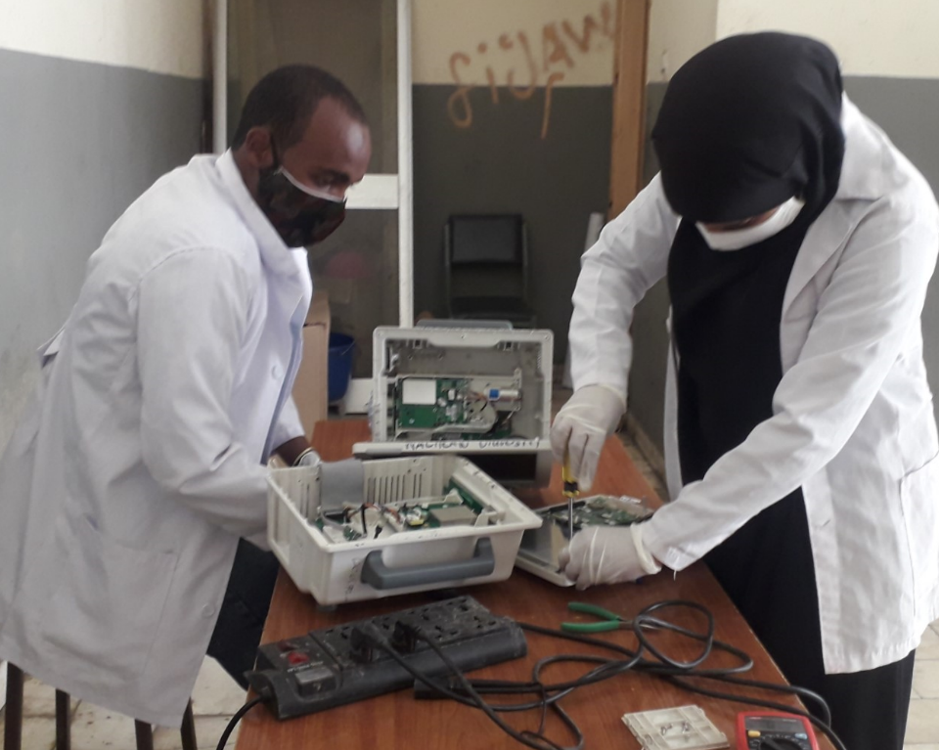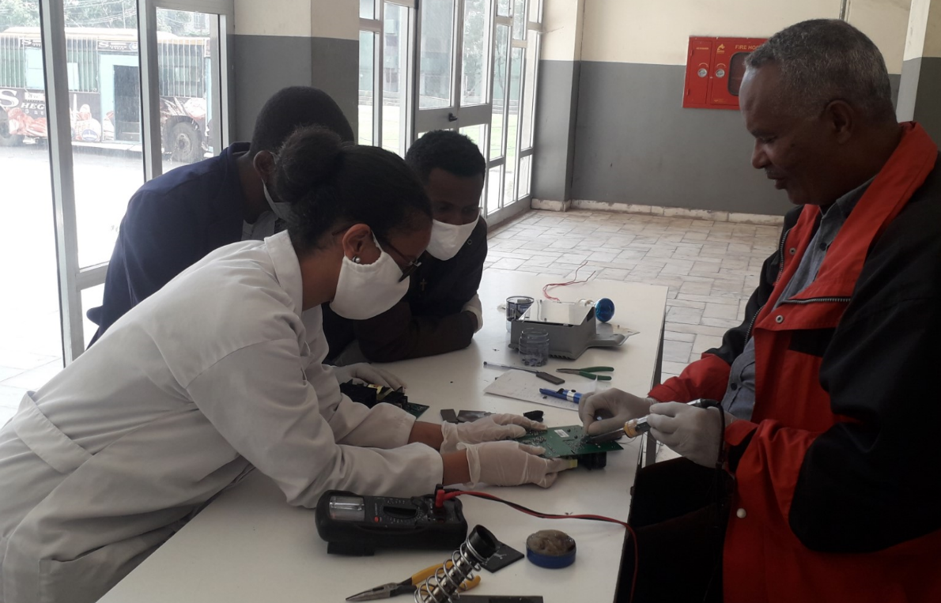

Figure 11: Maintenance on PMS

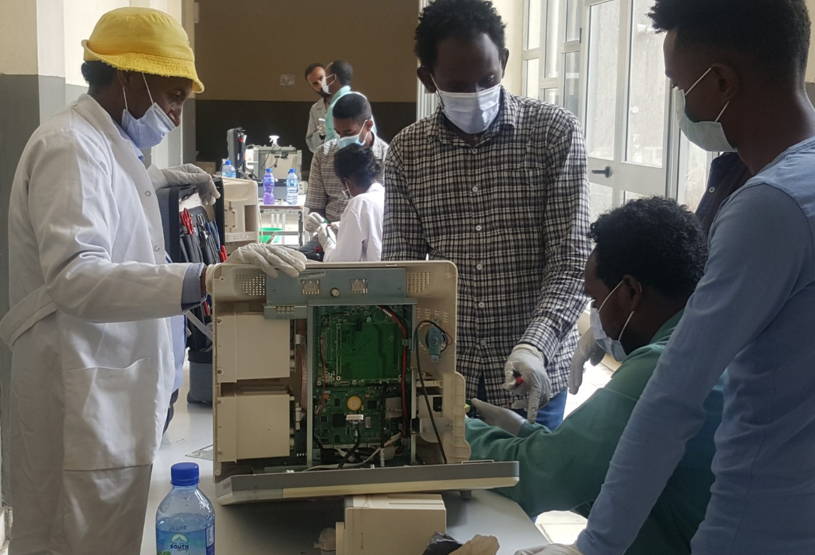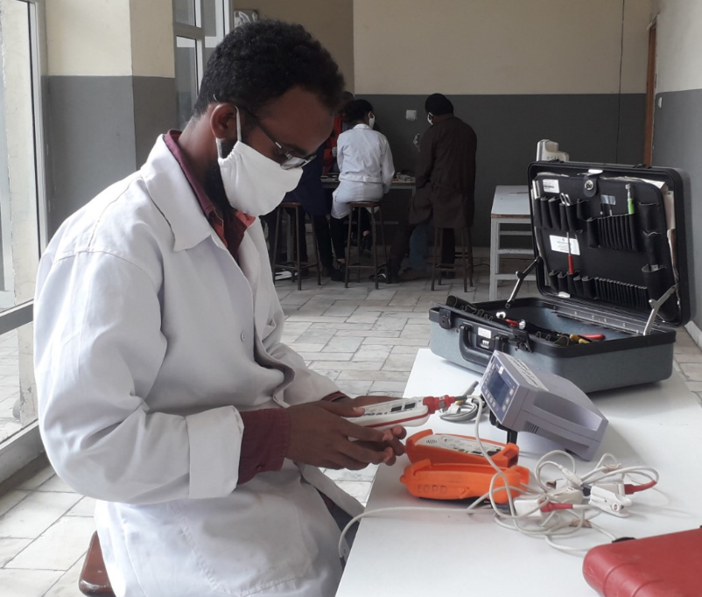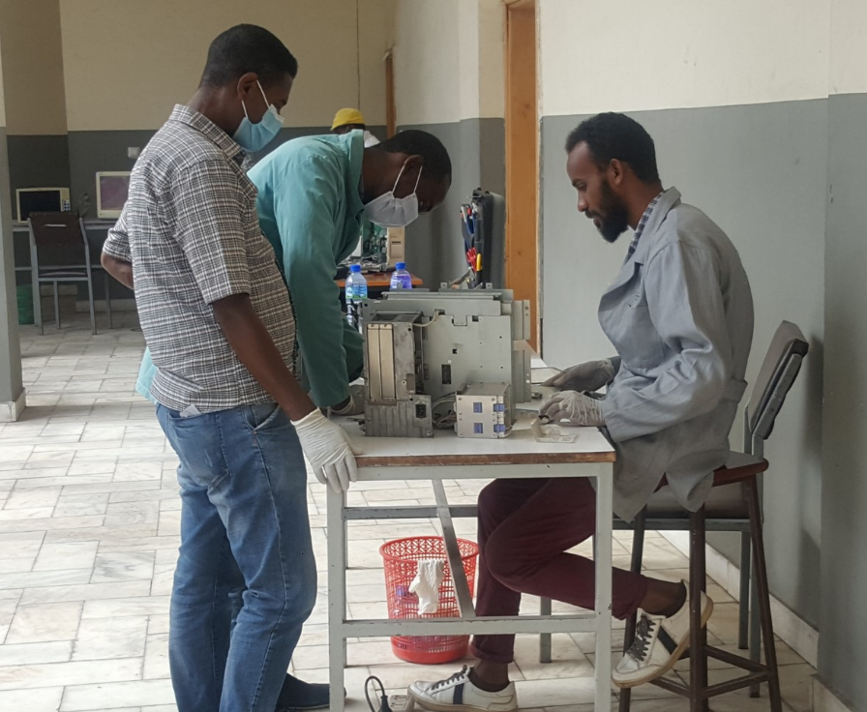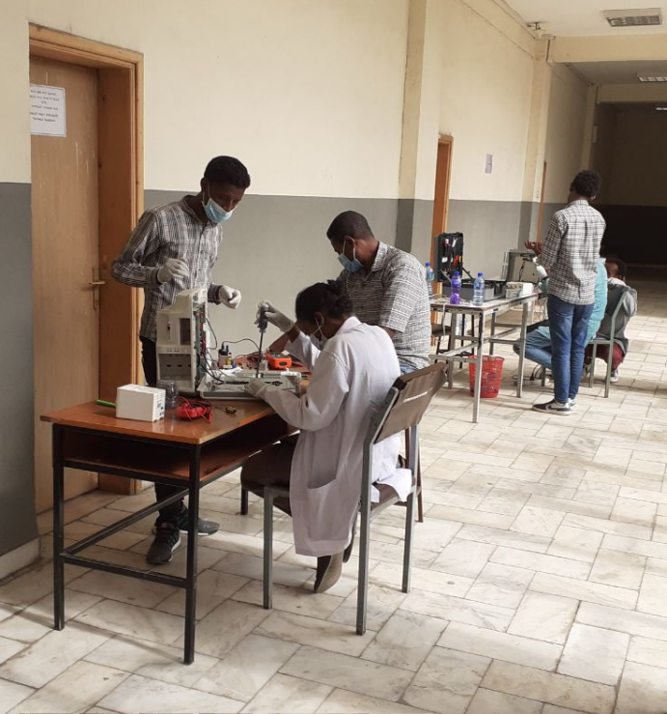

Figure 12: Maintenance on PMS and pulse oximeter units

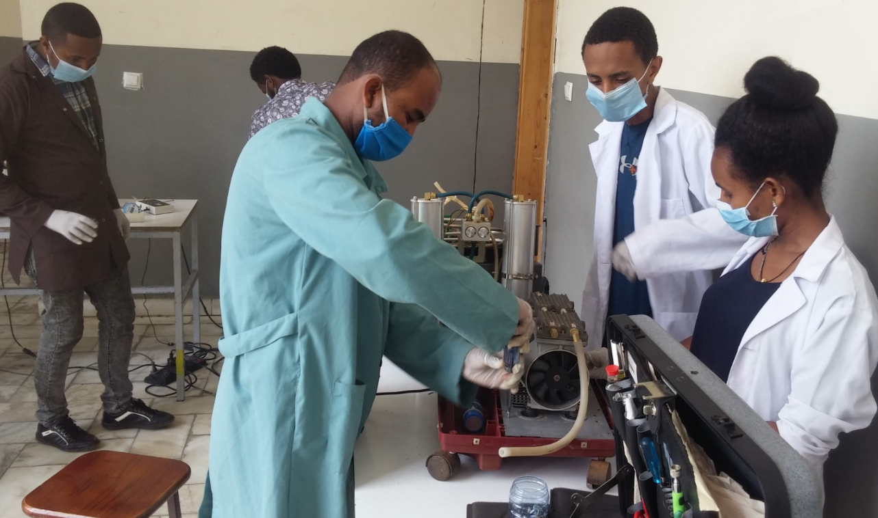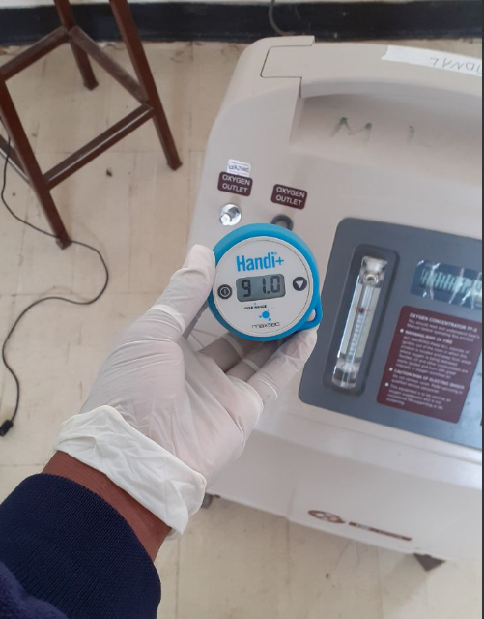

Figure 13: Maintenance on Oxygen concentrator unit

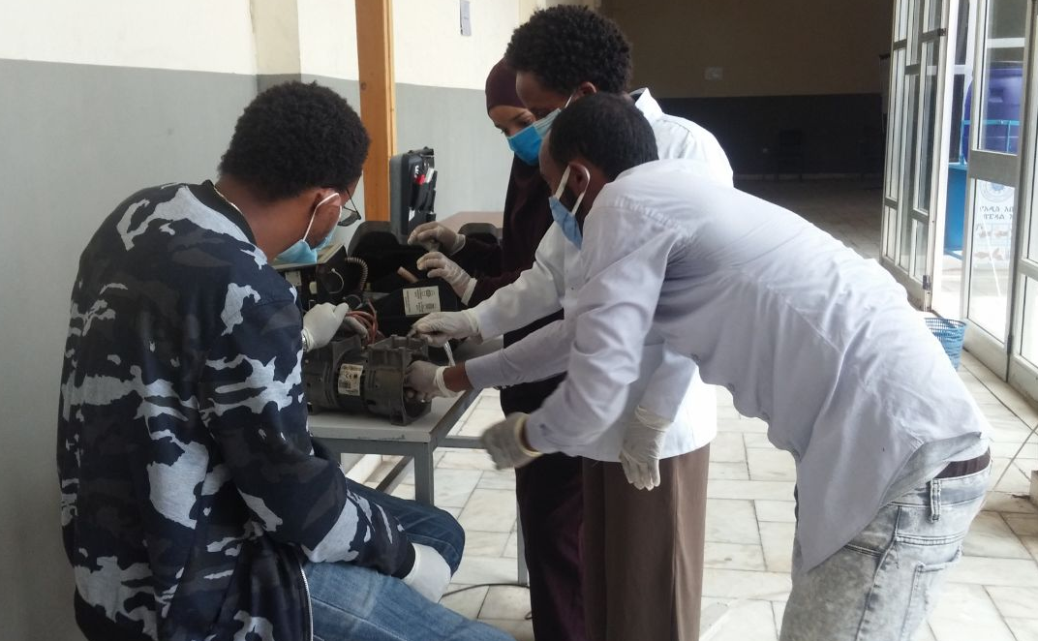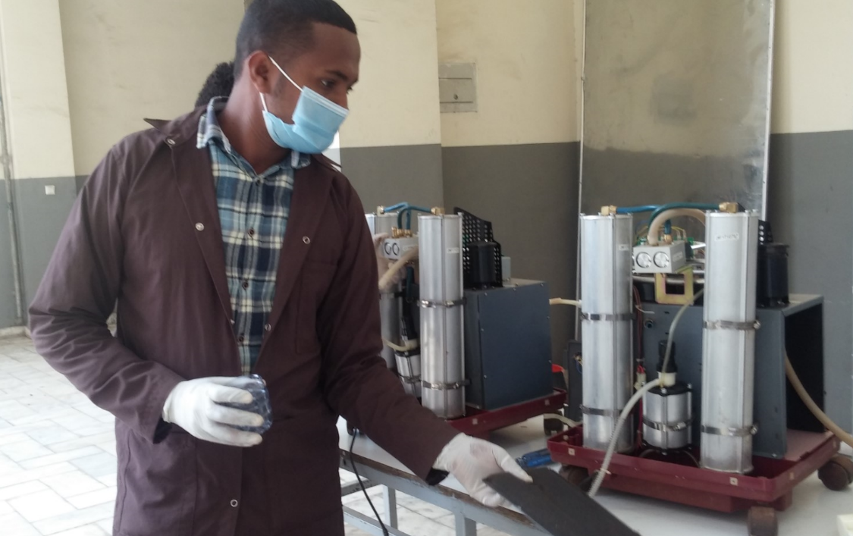

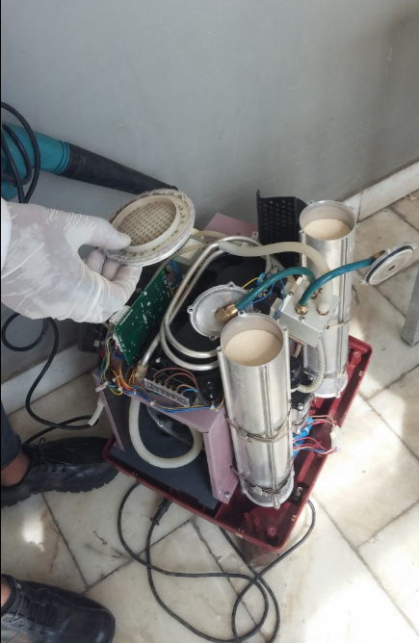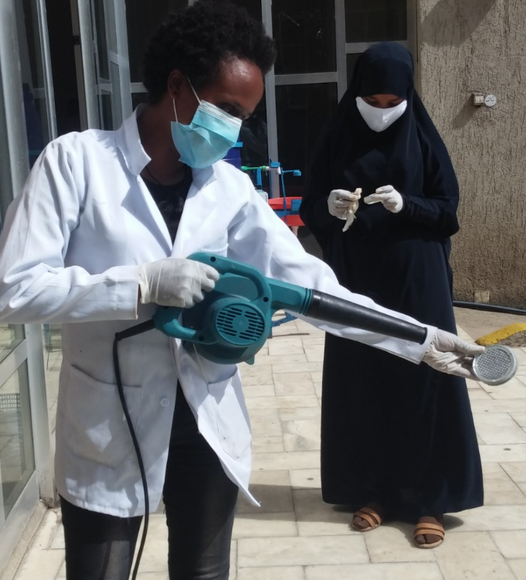

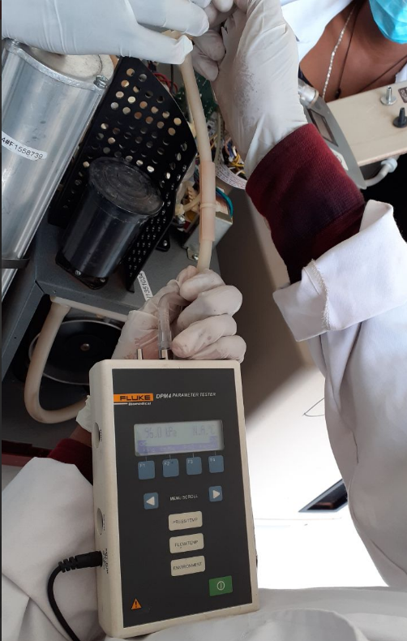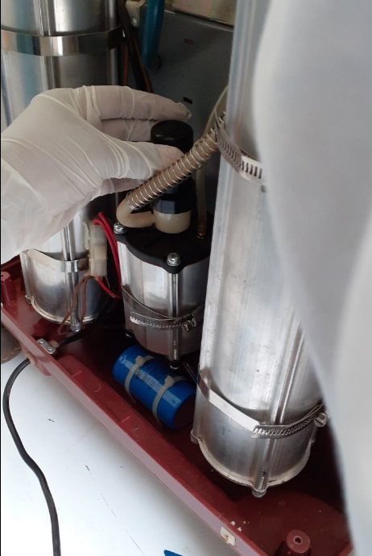

Figure 14: Maintenance of oxygen concentrator unit

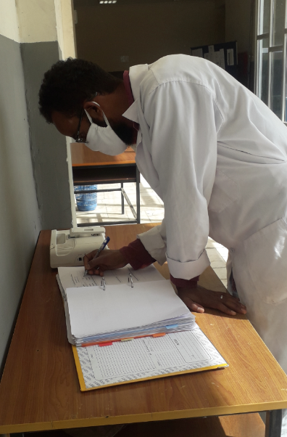

Figure 15: Filling maintenance form

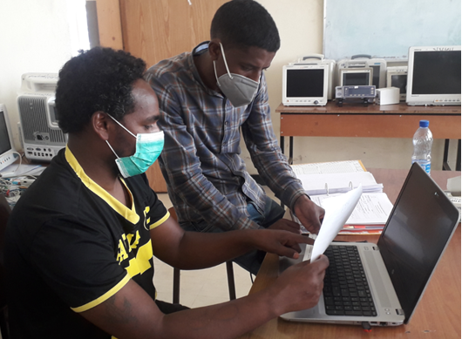

Figure 16: Documentation for accessory and spare part requirement

## Integration of Accessories

This is the stage where full availability of accessories is checked. On this and maintenance stage the department rely on the partners and interested donators to avail accessories and spare part needed to make the equipment functional. When all accessories become available they are plug in to the respective equipment and equipment is prepared for test and analysis.

## Test and Analysis

On this stage test and analysis of equipment is conducted. Retest is necessary to assure conducted maintenance activity, after which test and analysis form of the respective equipment is filled. If the equipment fails this stage it will be returned back for second round maintenance.

The medical equipment will pass through two kinds of test and analysis. One is “Performance Test” which is the process of determining its functionality. This is specific for the equipment. The second kind of test and analysis is “Electrical Safety Test” this is general for all equipment type.

So far test and analysis of 32 ventilator unit in the airport workshop was conducted by the biomedical department in AATPTC. To conduct test and analysis for the functional equipment in the workshop, accessories and parts are required. We have currently sent request list of accessories and sparepart to our partners and waiting for their arrival.

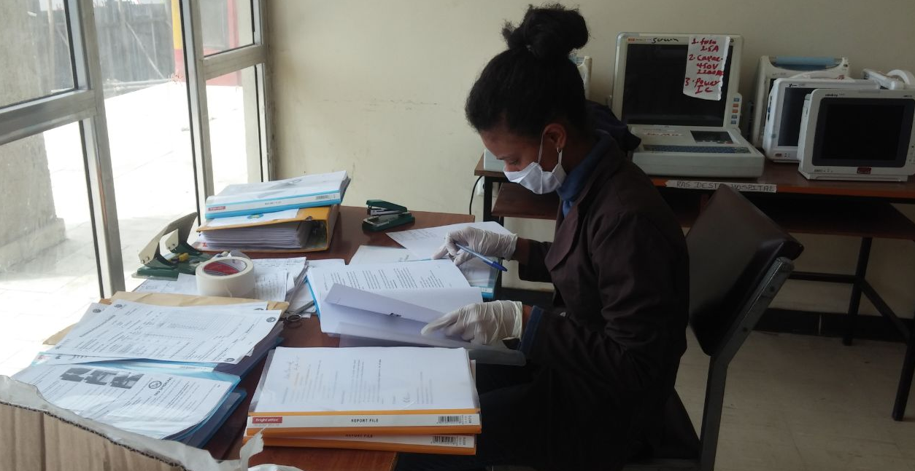

Figure 17: Reading through manual to develop test and analysis form

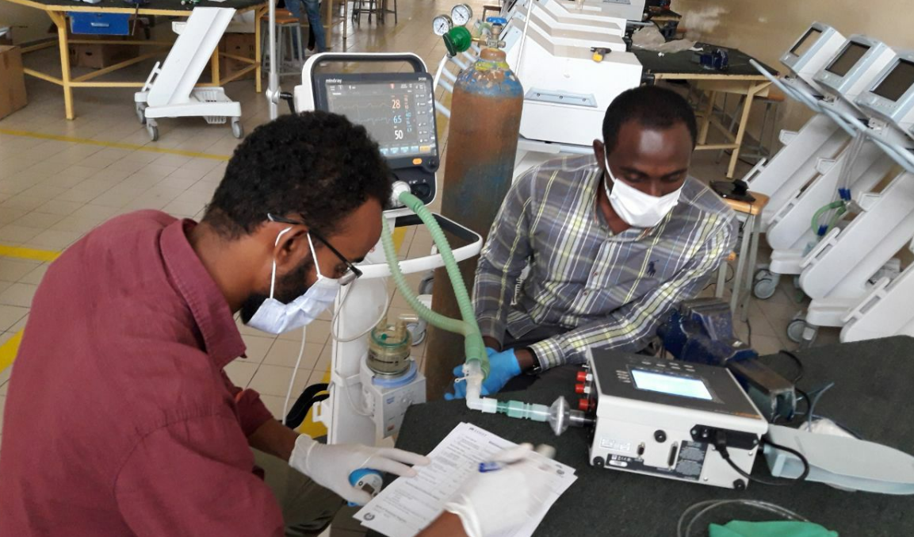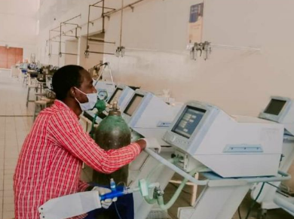

Figure 18: Conducting performance test on a ventilator unit

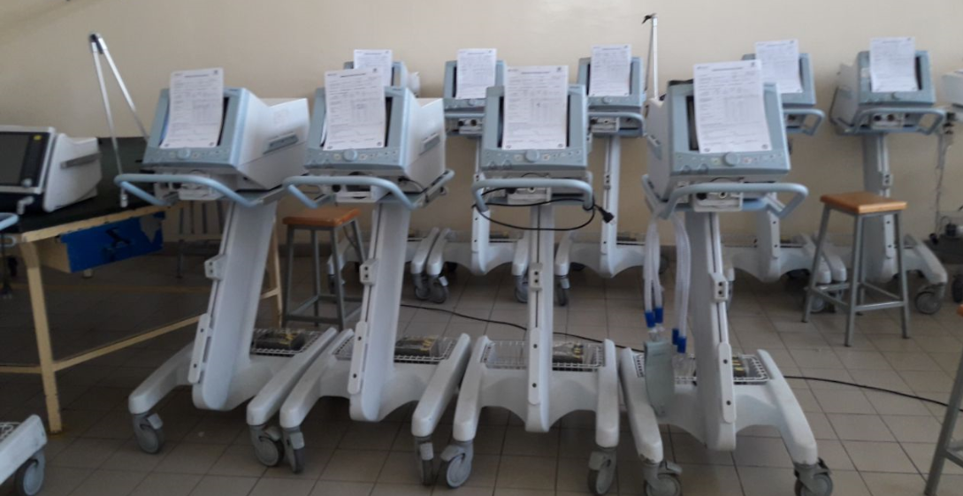

Figure 19: Analyzed mechanical ventilators at airport workshop

## Decommission

This is the stage where the owner receives their medical equipment back. Decommissioning form is filled. The department has recognized that follow up is necessary, so it’s in our plan to provide user training and technical support whenever necessary. Refer to the “Future Plan” section for more information on this. So far no equipment has been fully decommissioned.

# Spare Parts and Accessories Required

**Please refer to the Microsoft excel sheets on COVID19 Equipment Spare Part and accessory requirement list attached with this document.**

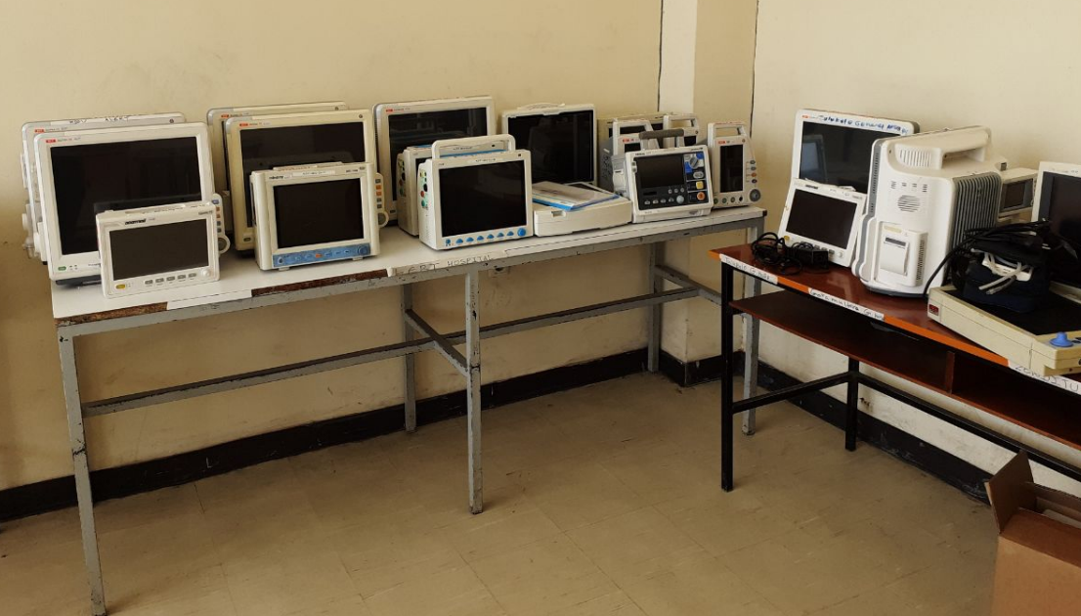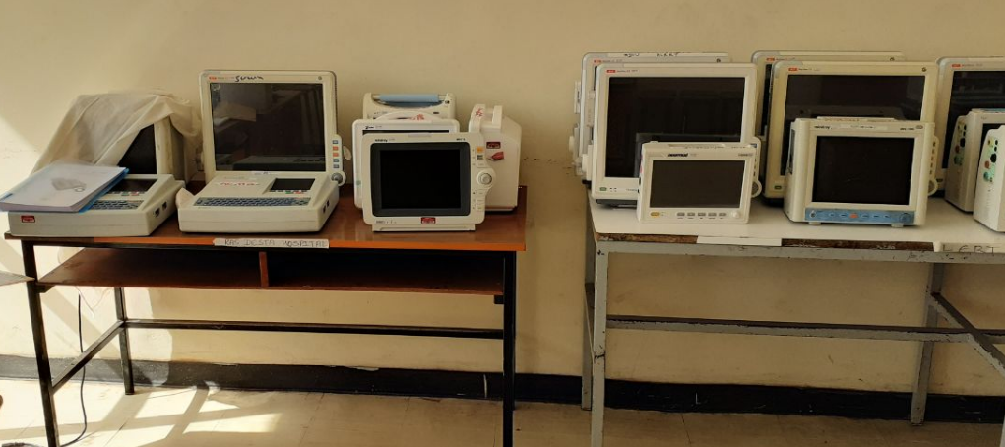

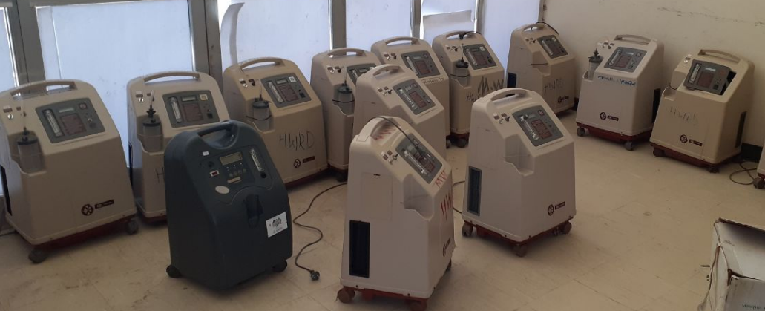

Figure 20: Equipment waiting for part and accessory (PMS. ECG and oxygen concentrators)

Mechanical Spare Parts and Material for Medical Devices under Repair

By M.Salamon, AATPTC, rev. 20.5.2020

|  |  |  |  |  |  |  |  |  |
| --- | --- | --- | --- | --- | --- | --- | --- | --- |
| **Pos.** | **Item** | **Specification** | Min. **Qty** in need | **Device Typ** | **Estim. Price/ Unit [EUR]** | **Total Price in [EUR]** | **Potential Source** | **Remark** |
| 1 | Si-Tube | Silicone, OD 10mm, ID 6mm, medical grade | 50m | O2 Concentr. | 2.84 | 284.00 | Carl Roth GER  Novoplast GER  Qosina USA |  |
| 2 | Si-Tube | Silicone, OD 8mm, ID 5mm, medical grade | 50m | O2 Concentr. | 2.62 | 262.00 | Carl Roth GER  Novoplast GER  Qosina USA |  |
| 3 | Si-Tube | Silicone, OD 15mm, ID 8mm, medical grade | 25m | O2 Concentr. | 9.55 | 238.75 | Carl Roth GER  Novoplast GER  Qosina USA |  |
| 4 | Si-Tube | Silicone, OD 6mm, ID 3mm, medical grade | 50m | O2 Concentr. | 1.55 | 77.50 | Carl Roth GER  Novoplast GER  Qosina USA |  |
| 5 | Si-Tube | Silicone, OD 1.5mm, ID 1mm, medical grade | 25m | O2 Concentr. | 5.13 | 128.25 | Carl Roth GER  Novoplast GER  Qosina USA |  |
| 6 | Si-Tube | Silicone, OD 1mm, ID 0.5mm, medical grade | 25m | O2 Concentr. | 4.37 | 109.25 | Carl Roth GER  Novoplast GER  Qosina USA |  |
| 7 | PVC-Tube | PVC-Tube, OD 4.1mm, ID 3mm, medical grade | 50m | O2 Concentr. | 1.56 | 78.00 | Carl Roth GER  Novoplast GER |  |
| 8 | PVC-Tube | PVC, OD 3.2mm, ID 1.8mm, medical grade | 50m | O2 Concentr. | 1.27 | 63.50 | Carl Roth GER  Novoplast GER |  |
| 9 | PA-Tube | PA, OD 6mm, ID 4mm, medical grade | 20m | O2 Concentr. | 3.14 | 62.80 | Dahlhaus GER  Novoplast GER  Reichelt RCTGER |  |
| 10 | PUR-Tube | PU, OD 10mm, ID 6mm, medical grade | 10m | O2 Concentr. | 15.40 | 154.00 | Dahlhaus GER  Novoplast GER  Reichelt RCTGER |  |
| 11 | PVC-P-Hose | Fiber reinforced PVC tube,  OD 16mm, ID 10mm | 10m | O2 Concentr. | 13.28 | 132.80 | Dahlhaus GER  Novoplast GER  Reichelt RCT GER |  |
| 12 | T-hose connector | PA, OD 8mm, ID 3mm | 50 pieces | O2 Concentr. | 1.08 | 54.00 | HSK-Handel GER  Carl Roth GER  Qosina USA |  |
| 13 | Hose connector | PA, OD 8mm, ID 3mm | 50 pieces | O2 Concentr. | 0.92 | 46.00 | Reinhard Weidlich Gesundheitsmarketing  [sauerstoffprofi@t-online.de](mailto:sauerstoffprofi@t-online.de) GER  Carl Roth GER  Qosina USA |  |
| 14 | m-LL hose connector | PA or PVC, male Luer Lock to ID 3mm | 50 pieces | O2 Concentr. | 1.19 | 59.50 | neoLab Migge GmbH GER, Carl Roth GER | Maybe available in Ethiopia |
| 15 | f-LL hose connector | PA or PVC, female Luer Lock to ID 3mm | 50 pieces | O2 Concentr. | 1.19 | 59.50 | neoLab Migge GmbH GER, Carl Roth GER | Maybe available in Ethiopia |
| 16 | Stopcock | PC or PVC, Luer Lock-Stopcock ID 1.8mm | 30 pieces | O2 Concentr. | 3.12 | 93.60 | neoLab Migge GmbH GER, Carl Roth GER | Maybe available in Ethiopia |
| 17 | 3/2 Valve | PC or PVC, Luer Lock-2-way valve, ID 1.8mm | 30 pieces | O2 Concentr. | 4.02 | 120.60 | neoLab Migge GmbH GER, Carl Roth GER | Maybe available in Ethiopia |
| 18 | m-LL Plug | PA or PVC, Male Luer Lock | 30 pieces | O2 Concentr. | 1.12 | 33.60 | neoLab Migge GmbH GER, Carl Roth GER | Maybe available in Ethiopia |
| 19 | f-LL Plug | PA or PVC, Female Luer Lock | 30 pieces | O2 Concentr. | 0.82 | 24.60 | neoLab Migge GmbH GER, Carl Roth GER | Maybe available in Ethiopia |
| 20 | Coarse Air Filter | PEs, Filter Mat, Class G2, W80mmxL210mmxT10mm, Unit 2x3m, T10mm, | 1 Unit | O2 Concentr. | 163.62 | 163.62 | Reichelt RCT GER | Bulk to be cut to fit |
| 21 | Bacteria Filter | HEBA Filter, Diameter 53, combined hose connectors for ID 6mm and 8mm tubes | 50 pieces | O2 Concentr. | 9.25 | 362.00 | HSK-Handel GER  Carl Roth GER |  |
| 22 | Humidifier | Yuwell, Humidifier, set of vessel, cup and connectors | 20 pieces | O2 Concentr. | 15.50 | 310.00 | HSK-Handel GER  DHdate.com CN  Reinhard Weidlich Gesundheitsmarketing  [sauerstoffprofi@t-online.de](mailto:sauerstoffprofi@t-online.de) GER |  |
| 23 | Hose clamp | Stainless steel, hose clamp, W 9mm, diameter 10 to 16mm | 50 pieces | O2 Concentr. | 1.50 | 75.00 | Reichelt RCT GER |  |
| 24 | Wire wraps | PA, Nylon, transparent, 96mmx2.5mm, 200/Pack | 6 pack | O2 Concentr. | 13.00 | 78.00 | Reichelt RCT GER  Conrad GER |  |
| 25 | Castor wheels | Snap in type stud, Overall dim. Stem Length 1.5in, Stem diam .4375in, Wheel Diam 2in, Wheel Width 1.625in | 40 pieces | O2 Concentr. | 2.89 | 115.60 | HomeDepots in US, DHdate.com CN |  |
| 26 | Gas Flow Regulator | Rotameter, LZQ-4, 1-5ltr/min, 115mm | 25 pieces | O2 Concentr. | 11.96 | 299.00 | DHdate.com CN |  |
| 27 | Sieve Bed Filter material | 13X Zeolite, molecular sieve, 3.5 Kg canister | 8 canisters | O2 Concentr. | 23.49 | 187.92 | Zeochem AG Swiss  Giebel FilTec GER |  |
| 28 | PVC-Tube | PA, OD 10mm, ID 6mm, medical grade | 50 m | O2 Concentr. | 3.56 | 178.00 | Dahlhaus GER  Novoplast GER  Reichelt RCTGER |  |
| 29 | Angle Adaptor | 90 degr. Adaptor, hose connector 6mm to UNF 9/16" thread | 25 pieces | O2 Concentr. | 2.54 | 63.50 | HSK-Handel GER  Reinhard Weidlich Gesundheitsmarketing  [sauerstoffprofi@t-online.de](mailto:sauerstoffprofi@t-online.de) GER |  |
| 30 | Air Filter Cartridge | ? | 20 pieces | O2 Concentr. | ? |  | ?? | Maybe substitute repair |
| 31 | Air Filter Cartridge | ? | 10 pieces | O2 Concentr. | ? |  | ?? | Maybe substitute repair |
| 32 | O2 face Mask for adults | Asid Bonz O2 face Mask for adults, incl. 2.2m safety tube, medical grade PVC | 100 pieces | O2 Concentr. | 1.95 | 195.00 | HSK-Handel GER |  |
| 33 | Sealing Tape | LOCTITE® 55 Sealing wire Colour White 2056936 160 m | 4 rolls | Repair shop | 18.33 | 73.32 | Conrad Electronic International GmbH & Co. KG GER |  |
| 34 | Adhesive | Pattex Stabilit Express Two-component adhesive PSE13 30 g | 6 pack | Repair shop | 10.83 | 64.92 | Conrad Electronic International GmbH & Co. KG GER |  |
| 35 | Adhesive | LOCTITE® 4860 Superglue 373355 20 g | 3 pieces | Repair shop | 34.99 | 104.97 | Conrad Electronic International GmbH & Co. KG GER |  |
| 36 | Sealant | TOOLCRAFT Blacksil Silicone Colour Black SIB.K80 80 ml | 10 pieces | Repair shop | 5.83 | 58.30 | Conrad Electronic International GmbH & Co. KG GER |  |
| 37 | Shrink Tube | DSG Canusa 8014060000 Heat Shrink Tubing 1.5 m, | 10 pieces | Repair shop | 3.99 | 39.90 | Conrad Electronic International GmbH & Co. KG GER |  |
| 38 | Shrink Tube | DSG Canusa 8014090000 Heat Shrink Tubing 1.5 m, | 10 pieces | Repair shop | 3.99 | 39.30 | Conrad Electronic International GmbH & Co. KG GER |  |
| 39 | Shrink Tube | Heat-shrink tubing set 1000 Parts Black, Transparent, 1 set | 3 sets | Repair shop | 59.99 | 179.97 | Conrad Electronic International GmbH & Co. KG GER |  |
| 40 | Hot Air Blower | Bosch Professional 06012A6200 GHG 20-63 Hot air blower 2000 W | 1 piece | Repair shop | 108.33 | 108.33 | Conrad Electronic International GmbH & Co. KG GER |  |
| 41 | Oxygen Analyzer IRC 450 | ‘Invarcare Check O2 plus’ Oxygen Analyzer IRC 450, incl. bateries, flow range 0-10l/min +/- 0.2, O2: 20.5-96% +/-1.5%, pressure 0.5-50psi +/-0.5% | 1  piece | Repair shop | 900.00 | 900.00 | Gloor Rehab&Co AG Swiss | 3 in 1 test unit for efficient testing |
| 42 | USB Microskope | TOOLCRAFT USB microscope with monitor 5 MP Digital zoom (max.): 500 x | 1 piece | Repair shop | 154.83 | 154.83 | Conrad Electronic International GmbH & Co. KG GER | Identification, comp. labels, doc. and comm. |
| 43 | Tool Set | Gedore 2836181 Tool kit Bag 9-piece 3K-slotted screwdriver 4/5.5/6.5 mm,3 K-cross slit PH 1/PH 2, Voltage tester 220 - 250 V, slot 3 mm, Universal pliers 10", 15-way adjustable, Multiple pliers 180 mm, Power side cutter 180 mm, Tool card. | 2 sets | Repair shop | 109.17 | 218.34 | Conrad Electronic International GmbH & Co. KG GER | Insufficient now |
| 44 | Tool Set | iFixit Mako Driver Kit 145299-4 Bit, high precision. 64 Bit set, Slot, Phillips, Square socket, TORX socket, TA socket, Gamebit, Hex head, JIS in plastic box | 2 set | Repair shop | 36.66 | 73.32 | Conrad Electronic International GmbH & Co. KG GER | Insufficient now |
| 45 | Measuring Tool Set | Horex 2228 208, set of 8-pieces, Pocket caliper 150 mm, Outside micrometer 0 - 25 mm, Flat angle, Compass, Scriber, Hair ruler, Steel scale, grains, Wooden case. | 1 set | Repair shop | 79.49 | 79.49 | Conrad Electronic International GmbH & Co. KG GER | Insufficient now |

Total 6201.88 EUR

Table 9: Mechanical Spare Parts and Material for Medical Devices under Repair

# Future Plans

Besides the regular and extension biomedical equipment technology occupation training program, the AAPTC Biomedical department has long term plan of achieving different activities. These activities are described below briefly.

## Provide In-service training

In-service training is a process of staff development for the purpose of improving the performance of an incumbent holding a position with assigned job responsibilities. In-service training is problem-centered, learner-oriented, and time-bound series of activities which provide the opportunity to develop a sense of purpose, broaden perception of the clientele, and increase capacity to gain knowledge and mastery of techniques.

Generally the In service training may be broadly categorized into three different types: All of these types of training are needed for the proper development of extension staff throughout their service life.

1. Induction or Orientation Training

Induction training is given immediately after employment to introduce the new extension staff members to their positions. In this case, the department plans to provide the new graduate Biomedical Engineer, technicians and end user how to keep the daily maintenance for the medical devices.

### Refreshment Training

This training is offered to update and maintain the specialized subject-matter knowledge of the incumbents. Refresher training keeps the biomedical engineer and technicians and end users who are the frontline workers to update and enables them to add to the knowledge and skills they have already.

### On-the-Job Training

This is regularly scheduled training, such as fortnightly training under the training and visit system of extension, and is provided by the superior officer or the subject-matter specialists to the subordinate field staff.

Therefore Addis Ababa Tegbare-id polytechnic College Biomedical equipment technology department plans to provide the CPD activities align with the FMOH and regional health bureau as before.

For example we a plan to provide training on:

1. Maternal and Child health device
2. Laboratory equipment
3. OR/Surgical equipment
4. Basic Electrical Electronics with machine drive
5. ICU Equipment
6. Maintenance Organization

## Establish medical equipment maintenance center

Currently a number of medical equipment in healthcare centers have malfunctioned and are out of service. The AATPTC biomedical department aim to provide maintenance service to this medical equipment and provide BMET and end user training for healthcare service providers.

Activities done in this regard are; visiting different hospital and health centers in the community under Lideta and Kirkos sub city by maintaining medical equipment and provide on job training for end users.

Strength of AATPTC Biomedical department to establish medical equipment maintenance center;

* Qualified trainers
* Skilled man power
* Well organized training and maintenance workshop
* Strategic area (workshop is found at the center of the city)

Weakness of AATPTC Biomedical department to establish medical equipment maintenance center;

* Missing dedicated workshop and lack of adequate equipment for elecromechanics/electronics
* Insufficient workshop for surgical equipment/ instrument, esp. mechanic workshop
* Spare Part access
* Service Manual Library
* Lack of accessories and consumables

## Conduct Performance test and analysis of medical equipment

Continuous assessment of performance test and analysis of medical equipment is essential and mandatory to provide quality healthcare service. It is a way of identifying the functionality and safety of the equipment during commissioning process and after maintenance before it gives service and be applied to patient.

This practice is not common in almost all hospitals in Ethiopia. There could be many reasons as to why this is; the analyzers and testing instruments are expensive and most hospitals cannot afford to buy, the biomedical engineers and technicians in the hospitals lack the knowhow of this and have not developed the habit, the analyzers and testing instruments have to be calibrated regularly and there is no access to the body that calibrates it here, lack of awareness in health technology management this list can go on. In order to fill this gap the department plans to work with its connection to the hospitals and healthcare centers to provide support and conduct the performance test and analysis needed.

With collaboration to PFSA and regulatory body (EFDA) the departments also have plan to conduct performance test and analysis of the new entry equipment and locally manufactured equipment before it is distributed to the facilities.

Strength of AATPTC Biomedical department to conduct performance test and analysis of medical equipment;

* Skilled and educated man power
* Analyzers and testing instruments
* Ethiopia TVET strategies

Weakness of AATPTC Biomedical department to conduct performance test and analysis of medical equipment;

* Certified personnel (to conduct test and calibration)
* Budget
* Insufficient support by Ethiopian Standard Agency, no established calibration scheme for medical devices
* Supplement of test equipment needed

## Establish capable incubation center

According to the Ethiopia TVET strategy one of the main tasks of the polytechnic college is technology transfer. This is aimed at solving the community problem in the healthcare system mainly in the medical equipment area. This task is run by technology transfer and industry extension vice dean of the college. The technologies are mainly developed by the help of the institute trainers. Joint product development project are also done in cooperation with local and national universities for technology transfer.

As a department to align with the TVET strategy the biomedical department plans to establish a more capable incubation center which provides expertise and technical support for any person with technology idea (innovative idea or copy from existing technology) so that idea can be developed. The support is intended to continue until the final prototype is manufactured and tested.

Strength of AATPTC Biomedical department to establish capable incubation center

* Skilled and educated man power
* Potential Space
* Organized workshop to test and verify prototypes
* The college have multidisciplinary department (e.g. electrical electronics and manufacturing)

Weakness of AATPTC Biomedical department to establish capable incubation center

* Lack of awareness about the incubation center
* Lack of seed capital for spin of medical device production enterprise
* Support of industries
* Fine mechanics equipment, 3D-printers, vacuum forming, fine casting, lab tool machines
* Simulation software like lab-view, solid works software
* Advertisement

# Appendix

## Acceptance form

|  |  |
| --- | --- |
| Description: C:\Users\LENOVO\Downloads\image.png | Covid-19 Medical Equipment Acceptance Form  Addis Ababa Tegbare-id Polytechnic College  Biomedical Technology Department, 2020 |
| Equipment Details | |
| Asset #*: Model:  Hospital Name: Serial number:  Equipment Name: Manufacture: | |
| Accessories | |
|  | |
| History/ Status | |
|  | |
| Owners information | |
| Name: e-mail:  Signature: Phone #:  Date of arrival: | |
| *Asset #: First two letter of hospital (abbreviation of hospital), number of equipment based on registration | |

## Standard of Operation

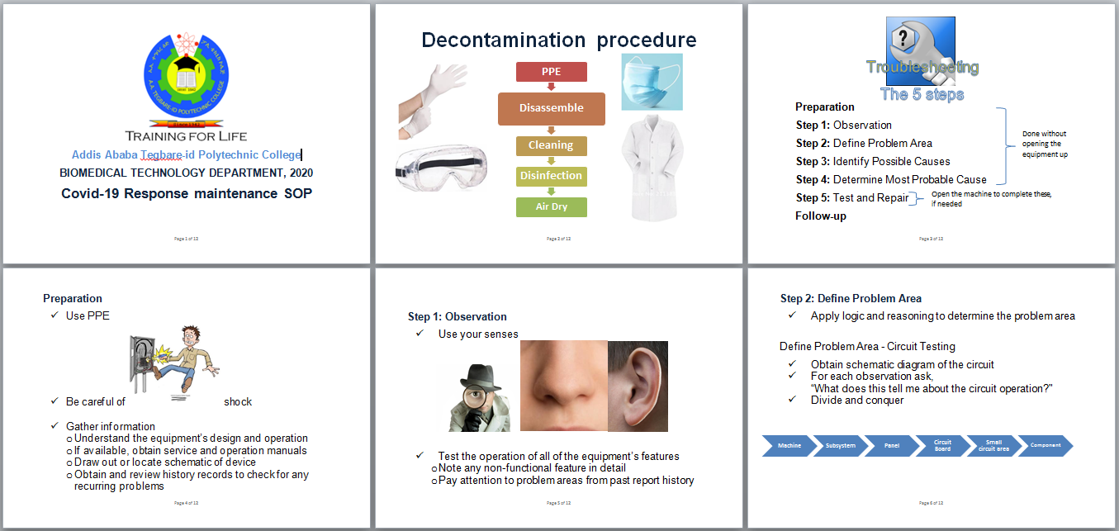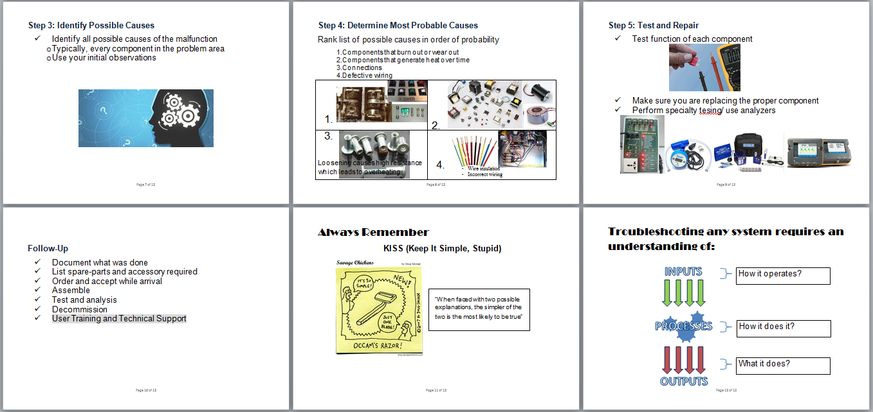

## Decontamination Guideline



**Addis Ababa Tegbare-id Polytechnic College**

**Biomedical and Legal Meteorology Technology Department, 2020**

**Guideline for Personal Safety and Decontamination of medical equipment**

The following guideline is developed with reference to world health organization (WHO) and other international guidelines.

The purpose of this guideline is to aid the professionals in the department of biomedical engineering/technology for maintaining their safety while maintaining and give direction on how to take precaution and decontamination process in low resource setting. Tegbare-id polytechnic college expects all hospitals to decontaminate all medical equipment brought to the college by the hospitals for maintenance or analysis.

The content of this guideline is divided in to three sections: The first section provides list of necessary equipment which are required for the safety of the professional doing the decontamination and maintenance. It provides lists of personal protective equipment (PPE), disinfectants, supply and tools required for decontamination. This would only refer to the ones that are easily accessible. On the second section is a brief note on safety and precautions guidelines states; that the professional has to follow before and while doing maintenance. Further it states glossary of the terms by WHO that are used in this guideline, as a recap for the biomedical engineer and technician to recall. The last section provides procedure on how to clean and disinfect medical equipment before starting maintenance in low resource setting.

For more and detailed information refer to the guidelines listed in the reference section.

**Section 1: Resources required**

**Personal Protective Equipment (PPE)**

* Gloves
  + Both latex and rubber gloves
* Face cover/visors
  + Face mask with goggles
* Aprons/gowns
* Closed shoes

**Cleaners and Disinfectant**

* Alcohol-based hand rub/ sanitizers
* Cleaning and disinfectants agents ( as per manufacture recommendation)

**Tools and Supplies**

* Brush
* Bucket/ bowl
* Water boiler(warm water)
* Soft towels/ non-linting disposable cloth
* Paper towels
* Water (Preferable distilled)

“Water hardness reduces the rate of kill of certain disinfectants and the efficiency of cleaning chemicals.”

**Section 2: Safety and precautions**

All medical equipment that has been in use in a hospital setting should be considered contaminated. Any personnel handling the equipment should use the PPEs stated in the first section. Contaminated devices shall not be transported through areas designated for the storage of clean or sterile supplies, visitor/patient/resident care areas or high-traffic areas. The most common method of verifying the cleaning process is by visual inspection. Manual cleaning cannot be validated; a clear SOP is required.

It is vital that all devices be disassembled so that all surfaces may be cleaned and disinfected irrespective of the cleaning method chosen. This guideline only considers manual cleaning as we are considering low resource setting. If your hospital requires other form of cleaning method please refer to WHO guideline for decontamination and reprocessing of medical devices for health-care facilities.

Other precautions to consider are:

* Ensure that the device to be cleaned is compatible with the chemical solutions used in the facility
* Remove gross soil using tools, such as brushes and single-use cloths
* Minimize the production of aerosols when cleaning non-immersible devices
* Some chemicals used for reprocessing are inactivated when mixed with other chemicals (incompatible)
* The life of the instruments is prolonged if soil and debris are removed regularly

**Glossary of Terms by WHO**

**Alcohol-based hand rub:** A liquid, gel or foam formulation of alcohol (e.g. ethanol, isopropanol), which is used to reduce the number of microorganisms on hands in clinical situations when the hands are not visibly soiled. They contain emollients to reduce skin irritation and are less time-consuming to use compared with hand washing.

**Cleaning:** The first step required to physically remove contamination by foreign material, e.g. dust, soil. It will also remove organic material, such as blood, secretions, excretions and microorganisms, to prepare a medical device for disinfection or sterilization.

**Contamination:** The soiling of inanimate objects or living material with harmful, potentially infectious or unwanted matter.

**Detergent:** A cleaning agent that increases the ability of water to penetrate organic material and break down greases and dirt. Detergents are needed to allow effective cleaning to take place.

**Disinfectant:** A chemical agent that is capable of killing most pathogenic microorganisms under defined conditions, but not necessarily bacterial spores. It is a substance that is recommended for application to inanimate surfaces to kill a range of microorganisms. The equivalent agent, which kills microorganisms present on skin and mucous membrane, is called an antiseptic.

**Disinfection:** A process to reduce the number of viable microorganisms to a less harmful level. This process may not inactivate bacterial spores, prions and some viruses.

**Decontamination:** Removes soil and pathogenic microorganisms from objects so they are safe to handle, subject to further processing, use or discard. (Centers for Disease Control and Prevention [CDC] Guidelines for Disinfection and Sterilization in Healthcare Facilities, 2008).

**Section 3: Decontamination**

The process of decontamination has three major steps. The first step is cleaning after which disinfection and sterilizations follow respectively. On this guideline only two of these will be discussed since the medical equipment referred is electrical or battery-powered devices and those that cannot be sterilized.

It is highly recommended to follow decontamination guideline that the medical equipment manufacturer provides. The methods listed below are to be used if the manufacturers’ guideline is not available. It is also necessary to note that this does not replace manufacturers guideline and is the least and basic procedure to follow in low resource setting.

**CLEANING**

Medical equipment that is electrically or battery-powered operated should not to be immersed in liquid solution.

**Non-immersion method**

* Clean the device by wiping surfaces thoroughly with a disposable, clean, non-linting cloth and detergent ensuring that moisture does not enter critical areas of the device (e.g. power connections) until all visible soil is removed
* Rinse the device by wiping surfaces thoroughly with a damp, disposable, clean, non-linting cloth until all detergent residue is removed
* Mechanically dry; if this is not available or not recommended by the manufacturer, air-dry or hand-dry using a disposable clean, non-linting cloth. *Disposable cloths should be discarded after each use
* Cleaning solution and water should be changed at each cleaning session and when visibly soiled.

**Note:** Chemical disinfection prior to cleaning is unnecessary, ineffective and of little value in the presence of organic matter.

For effective cleaning it is essential that the detergents are prepared at the concentration recommended by the manufacturer/supplier. To achieve the correct concentration, the correct volume of concentrated detergent has to be added to the correct volume of water at the correct temperature. The following calculation can be used:

Volume of detergent or chemical (supplied) = $\frac{concentration required x capacity of the sink/bowl (in ml)}{Concentration supplied}$ $\frac{concentration required x capacity of the sink/bowl (in ml)}{Concentration supplied}$

For example, if a 1% solution of detergent is required and the bucket/bowl capacity is 10 liters (10,000 ml) and the concentration supplied is 100%:

Volume of supplied detergent = 1 x 10,000/100 = 100

Therefore, 100 ml is used and made up to 10 liters to achieve a 1% solution. The detergent does not have to be measured precisely each time, but a fill line can be placed on the bucket/bowl and a galipot or jug used to measure the detergent.

**DISINFECTION**

For devices that cannot tolerate immersion in solution, manual disinfection using a clean cloth and a compatible chemical disinfectant shall be applied. The solution should be wiped over the device’s surface using a clean disposable cloth.

When using a chemical disinfectant, it is important to ensure that the disinfectant is at the correct concentration and is in contact with the device for the specified minimum contact time.

The disinfectant solution should be removed from the device with clean water and the device dried prior to storage. Air drying or wiping down with disposable paper towels are alternative techniques. Once dried, the devices should be stored to protect them from ‘cross-’ or re-contamination.

Disinfectants should be used and stored in accordance with the manufacturer’s instructions. This includes the use of lockable cupboards in which to store the chemicals. Use of personal protective equipment when handling chemicals will be required.

**Note:** Any disposable cloth/towel used for decontaminating equipment should be considered a biohazard and disposed of in accordance with the hospital policy (clinical waste).

**Dos and don’ts of cleaning**

**Do**

* Ensure detergent is prepared at the correct concentration and temperature and used for the recommended contact time
* Keep instruments moist and clean as soon as possible after the procedure
* Disassemble instruments prior to cleaning
* Open hinged/jointed instruments to ensure access to all surfaces
* Use appropriate sized brushes to clean lumened items
* Use soft bristle brushes to clean serrations and box locks
* Inspect instruments after cleaning
* Clean instruments under the surface of the water to reduce the risk of aerosol production
* Follow manufacturer’s instructions for the cleaning of all medical devices

**Don’t**

* Use metal brushes or any abrasive item when cleaning instruments
* Clean instruments under running water because this can produce aerosols
* Overload trays in a washer–disinfector
* Obstruct spray arms in a washer-disinfector
* Submerge power equipment or electrical items (unless they have a waterproof cap)
* Use a detergent that is not intended for medical devices

**Resource**

[1] WHO Library Cataloguing-in-Publication Data, Decontamination and Reprocessing of Medical Devices for Health-care Facilities, World Health Organization and Pan American Health Organization, [http://www.who.int](http://www.who.int/), 2016

[2] BHTA British Healthcare Trades Association, Decontamination of Medical Devices and other Assistive technology, Suite 4.6, [www.bhta.com](http://www.bhta.com/), 2018

Great gratitude goes to Mr. Ray Emslie for his expertise advice and comment.

Meba Hailu, 2020

## Maintenance Form

|  |  |
| --- | --- |
| Description: Description: C:\Users\LENOVO\Downloads\image.png | Covid-19 Medical Equipment Maintenance Form  Addis Ababa Tegbare-id Polytechnic College  Biomedical Technology Department, 2020 |
| Equipment Details | |
| Asset #*: Model:  Hospital Name: Serial number:  ‘Equipment Name: Manufacture: | |
| Decontamination (Cleaned, Disinfected, Sterilized, [Process]) | |
|  | |
| Troubleshooting (what has been done?) | |
|  | |
| Spare Part and accessories required | |
|  | |
| Remark/Status (Functional/Non-functional, [Reason for malfunction]) | |
|  | |

## Test and Analysis Form (ventilator unit)

|  |  |  |  |  |
| --- | --- | --- | --- | --- |
| Description: C:\Users\LENOVO\Downloads\image.png | Covid-19 Medical Equipment Test and Analysis Form  Addis Ababa Tegbare-id Polytechnic College  Biomedical Technology Department, 2020  **Unit: Mechanical Ventilator** | | | |
| 1. **Physical/ Qualitative tasks** | | | | |
| **Equipment data** | | | | |
| Manufacturer: ___________________ Hospital/Owner: _______________________  Model: _________________________ Location: ____________________________  S/N: ___________________________ Inventory.no:_________________________ | | | | |
| **Maintenance Type** | | | | |
| Corrective Preventive New unit | | | | |
| **Physical Condition and other tests (*tick ( ✓ ) where appropriate)*** | | | | |
| Condition to be verified | | Pass | Fail | N/A |
| Device is clean and decontaminated | |  |  |  |
| No physical damage to chassis, display, mount, component | |  |  |  |
| Caster/Brakes-verify condition | |  |  |  |
| A.C plug - verify physical integrity & proper insulation | |  |  |  |
| Control switches- verify proper operation of controls | |  |  |  |
| Alarm / Audible Signal -verify proper operation & automatic activation | |  |  |  |
| Battery charging- verify operation of battery and charge | |  |  |  |
| Indicator/display-verify proper illumination & operation | |  |  |  |
| Tube/hoses /gas connector- Check all tubes/ hoses/connectors | |  |  |  |
| Run extended Self-Test (EST) | |  |  |  |
| Compressor /air blower- verify proper operation | |  |  |  |
| Filter and vent clean | |  |  |  |
| Summary: | | | | |

|  |  |  |  |  |  |  |  |
| --- | --- | --- | --- | --- | --- | --- | --- |
| 1. **Performance test *(quantitative tests): Tick ( ✓ ) where appropriate*** | | | | | | | |
| ***Test parameter*** | ***UOM*** | ***Set values*** | ***Meas.***  ***values*** | ***Tolerance*** | ***Pass*** | ***Fail*** | ***N/A*** |
| 1.O2 failure alarm | N/A |  |  |  |  |  |  |
| 2.Air failure alarm | N/A |  |  |  |  |  |  |
| 3.PIP-peak inspiratory pressure | cmH2O | 30cmH2O |  | 29-31 |  |  |  |
| 1. O2 calibration | % | 21% |  |  |  |  |  |
| 100% |  |  |  |  |  |
| 5.Tidal volume (use 1L test lung) | ml | 300 |  | 270-330 |  |  |  |
| 500 |  | 450-550 |  |  |  |
| 700 |  | 630-770 |  |  |  |
| 6.Respiration rate(RR) | bpm | 12 |  | 11-13 |  |  |  |
| 18 |  | 17-19 |  |  |  |
| 24 |  | 23-25 |  |  |  |
| 7.O2 concentration  If the unit uses air/O2 mixer | % | 21% |  | 19-23 |  |  |  |
| 99% |  | 92-99 |  |  |  |
| 50% |  | 47-53 |  |  |  |
| 70% |  | 67-73 |  |  |  |
| 8.PEEP | cmH2O | 5 |  | 3-7 |  |  |  |
| 10 |  | 8-12 |  |  |  |
| 12 |  | 10-14 |  |  |  |
| ***Summary/comment on the test:*** | | | | | | | |
|  | | | | | | | |
|  | | | | | | | |
|  | | | | | | | |
|  | | | | | | | |
| **Test analyzer data:** | | | | | | | |
| Test device: Test device:  Model: Model:  S/N: S/N:  Calibration due date: Calibration due date: | | | | | | | |
| How long did the activity take? | | | | | | | |
| **Test done by:** | | | | | | | |
| **Name of BME/BMT Sign Date** | | | | | | | |

|  |  |  |  |  |  |
| --- | --- | --- | --- | --- | --- |
| 1. **Electrical Safety Test** | | | | | |
| **Analyzer /tester device data** | | | | | |
| **Analyzer Name:**  **Calibration due date:**  **Model:**  **S/N:** | | | | | |
| **Test parameter** | ***Measured value*** | **Tolerance**  **(IEC 62353)** | ***Test result*** | | |
| ***Pass*** | ***Fail*** | ***N/A*** |
| 1.Earth/Ground wire resistance |  | ***<0.3Ω*** |  |  |  |
| 2.Enclosure leakage / chassis leakage |  | ***<100µA ( NC)*** |  |  |  |
|  | ***<500µA (SFC)*** |  |  |  |
| *How long did the test take? _________* | | | | | |
| **Test done by:** | | | | | |
| **Name of BME/BMT Sign Date** | | | | | |

## Decommissioning Form

|  |  |  |
| --- | --- | --- |
| Description: Description: C:\Users\LENOVO\Downloads\image.png | Covid-19 Medical Equipment Decommissioning Form  Addis Ababa Tegbare-id Polytechnic College  Biomedical Technology Department, 2020 | |
| Equipment Details | | |
| Asset #*: Model:  Hospital Name: Serial number:  Equipment Name: Manufacture: | | |
| Decommissioning Process | | |
| The term “Decommissioning” is used here in the sense of removing the equipment from the biomedical department workshop and returning equipment to their respective hospitals. | | |
| Qualitative tasks- tick (✓) where appropriate | | |
| |  |  |  |  | | --- | --- | --- | --- | | **Description** | **Yes** | **No** | **N/A**  It is essential that equipment passes through all maintenance procedure before decommissioning.  If there is a requirement of an early decommissioning, state the reason clearly in the remark.  (*N/A- Not Applicable) | | Accepted |  |  |  | | Disassembled |  |  |  | | Decontaminated |  |  |  | | Assembled |  |  |  | | Maintained |  |  |  | | Accessories Integrated |  |  |  | | Tested & Analyzed |  |  |  | | | |
| Remark [AATPTC Biomedical Department] | | |
|  | | |
| Remark [Equipment owner] | | |
|  | | |
| Owners Signature of Acceptance | | **Release signature of Department** |
| Name:  Sign:  Date: | | Name:  Sign:  Date: |

*Witnesses sign on back of this page

|  |  |
| --- | --- |
| **Witness from owners side** | **Witness from department side** |
| Name:  Sign:  Date: | Name:  Sign:  Date: |
| Name:  Sign:  Date: | Name:  Sign:  Date: |